1. **Flight Reservation System**

Step -1: Go to Zoho.com and login

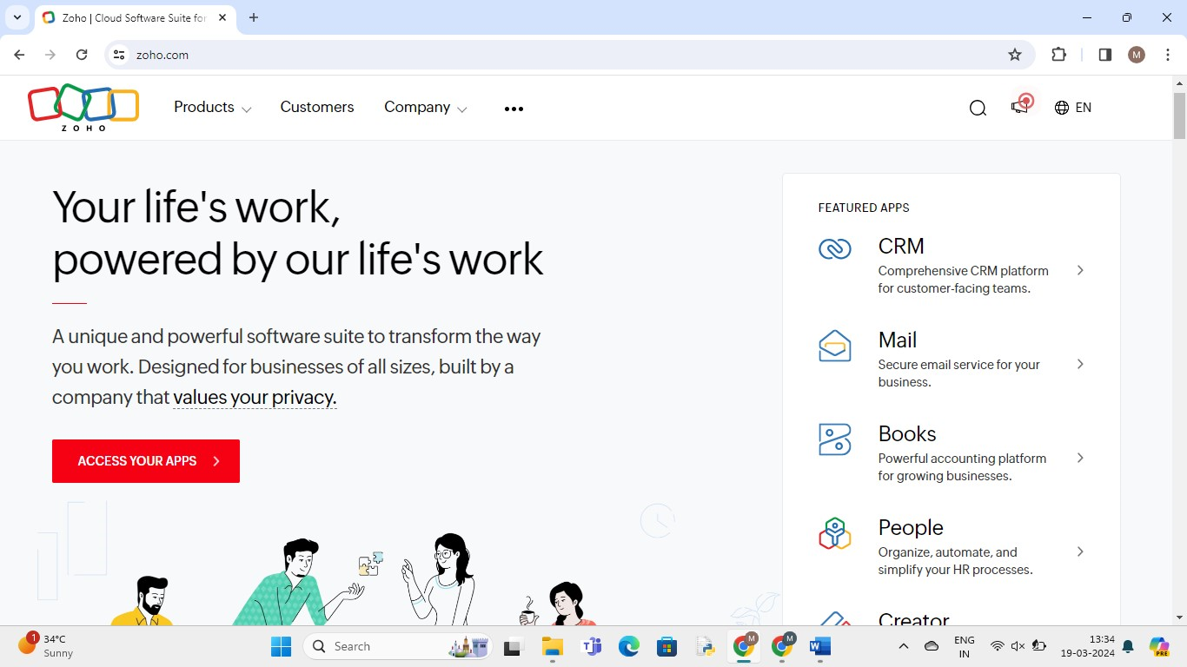

Step-2: Go to Creator

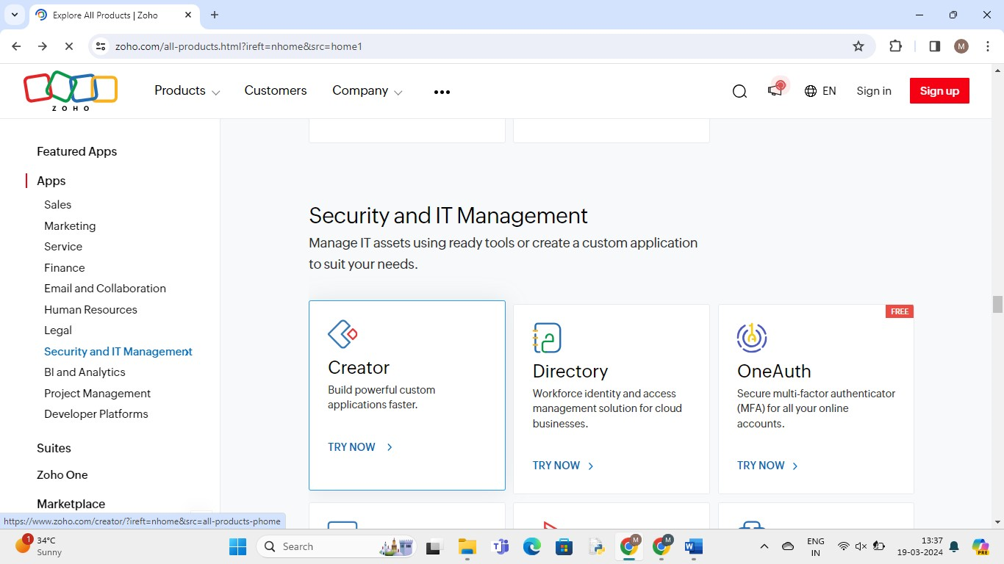

Step – 3: Create new application - scratch

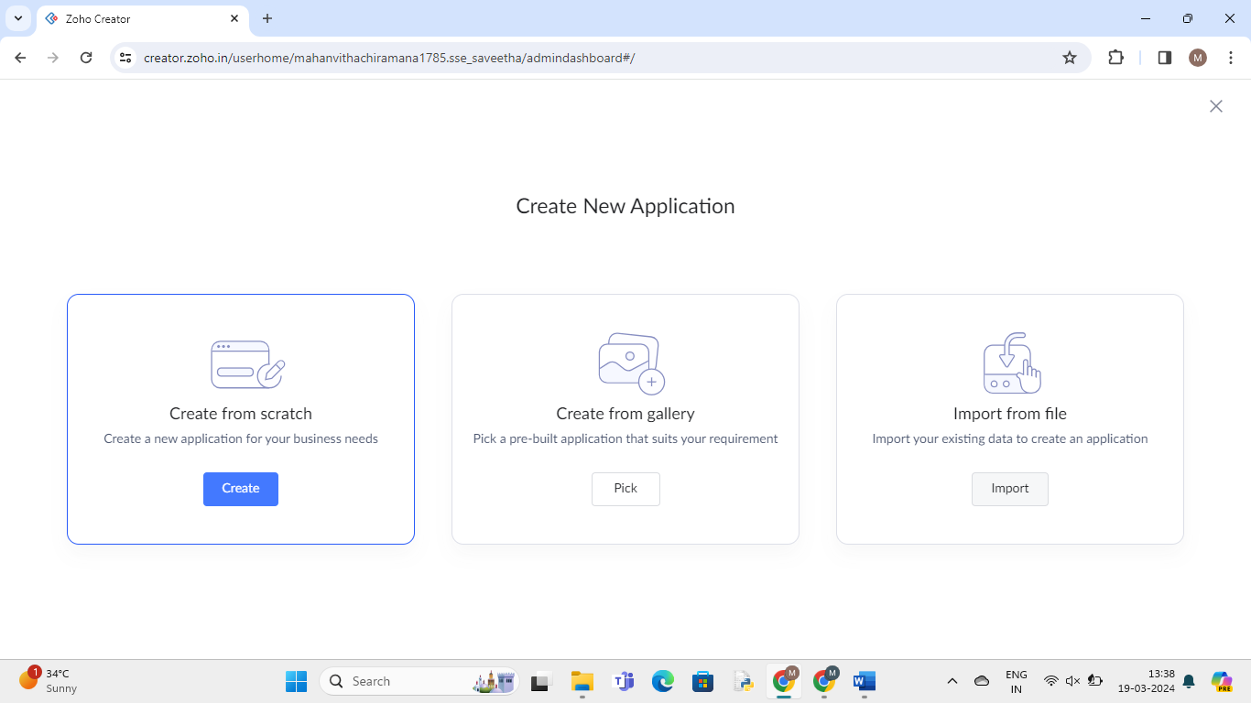

Step- 4: Give application Name

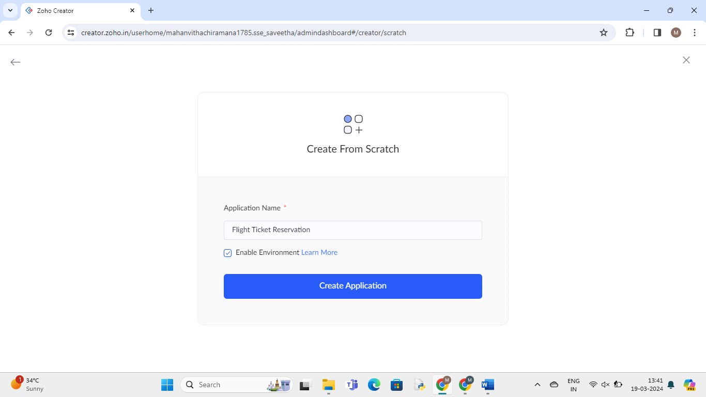

Step – 5: create new form and give name

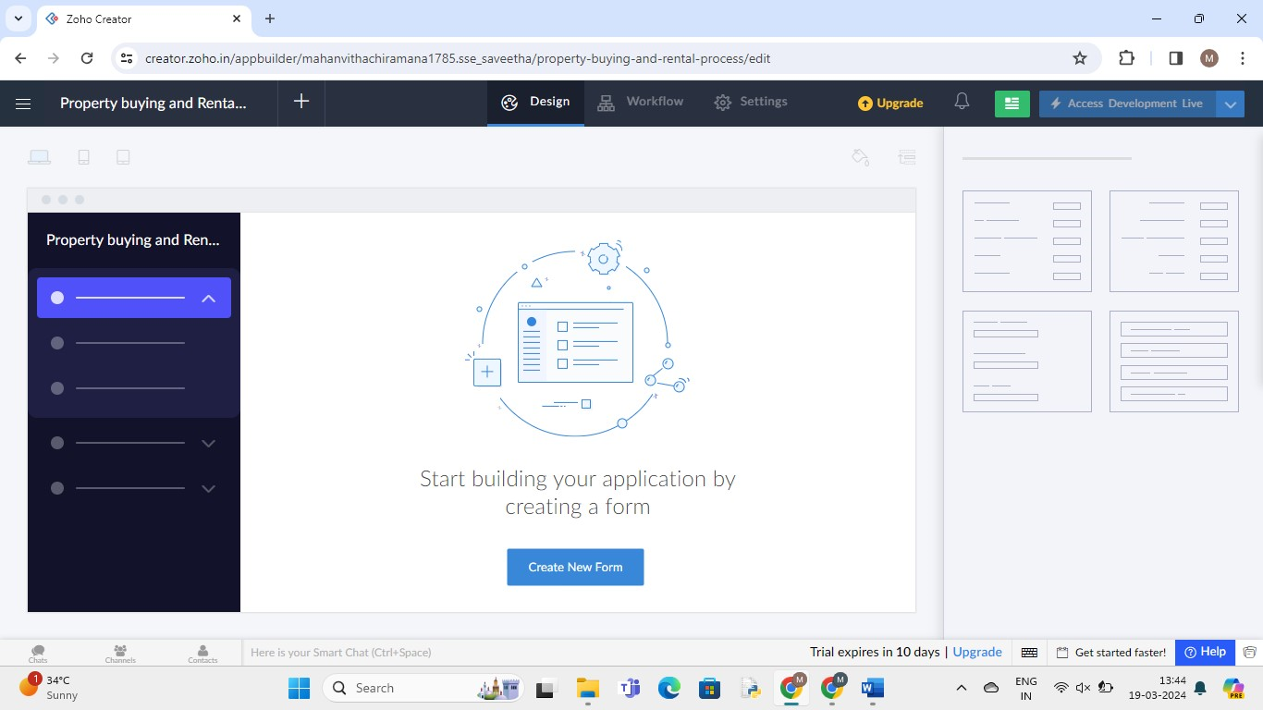

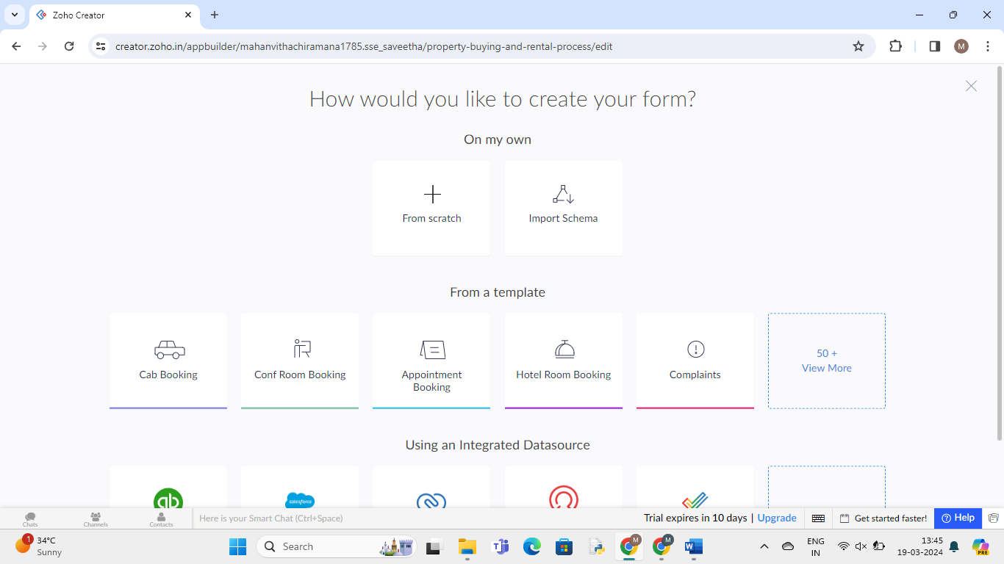

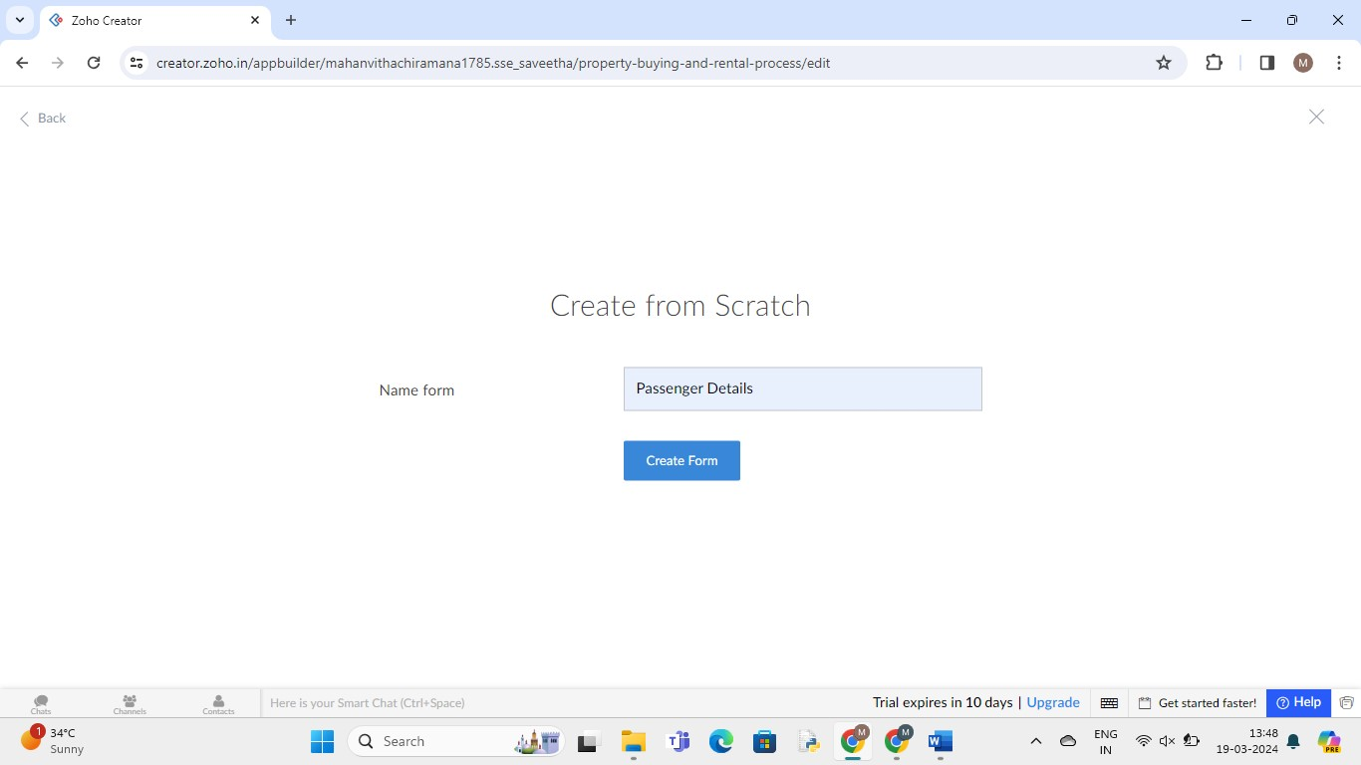

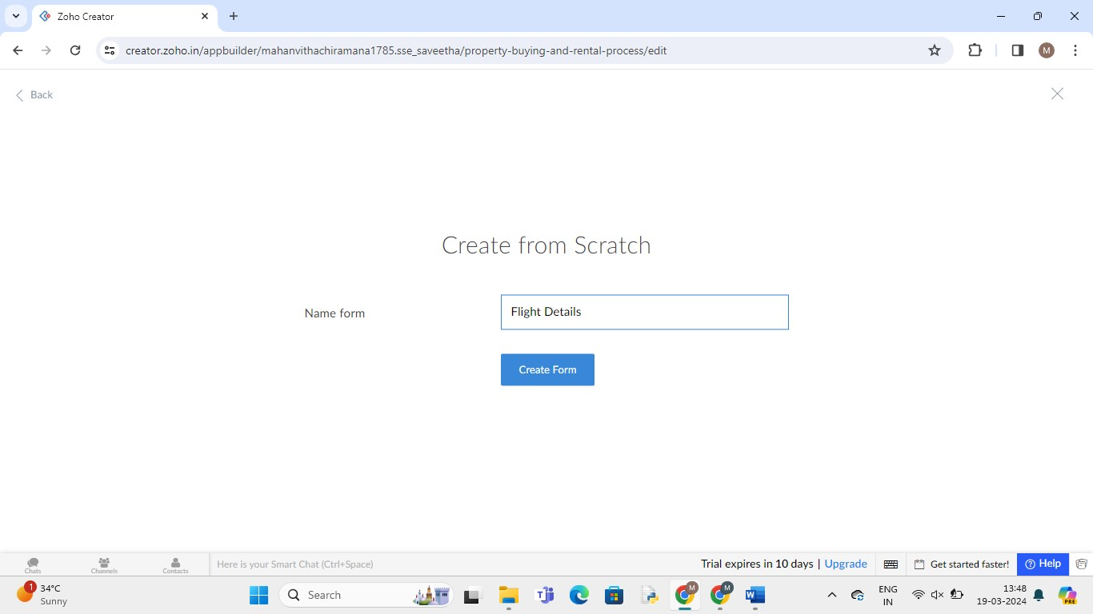

Step -6: Drag necessary fields

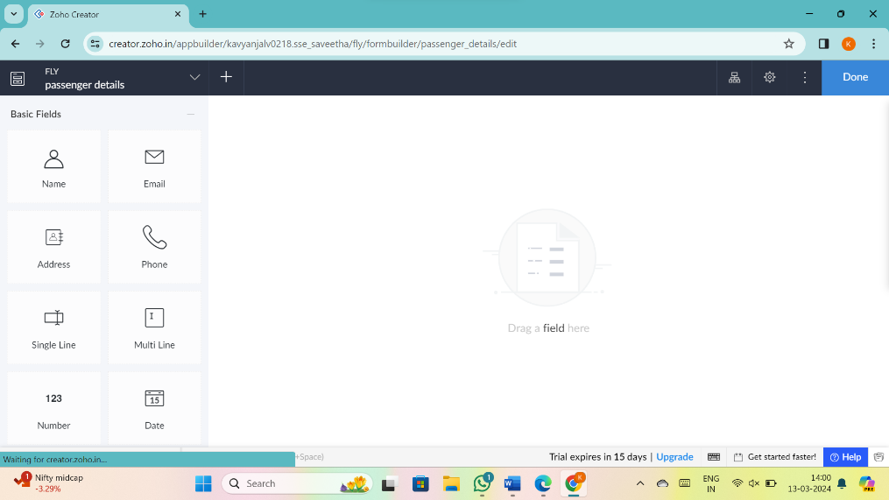

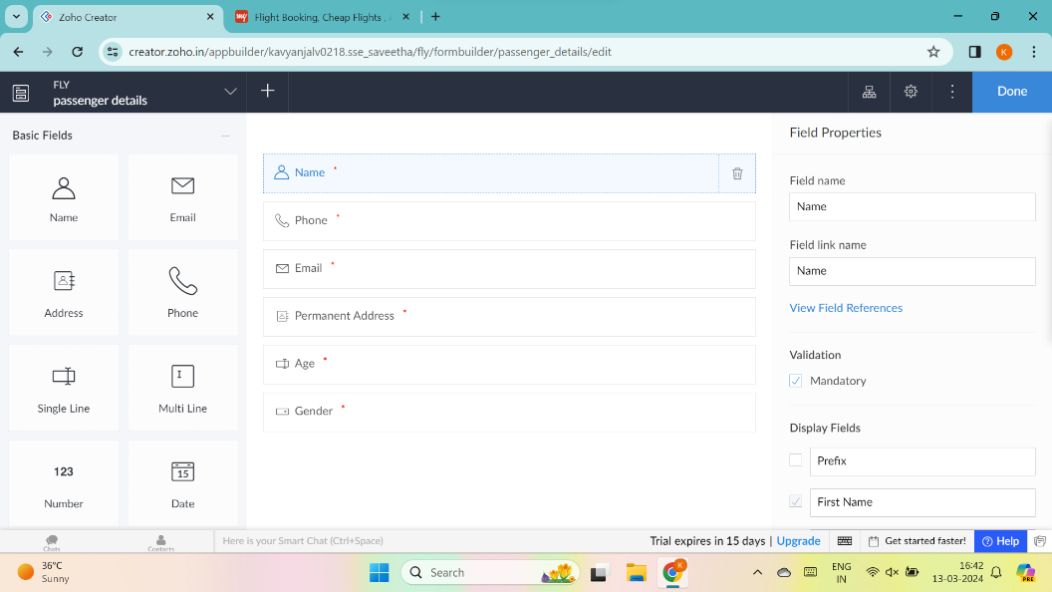

Step-7: Enter details

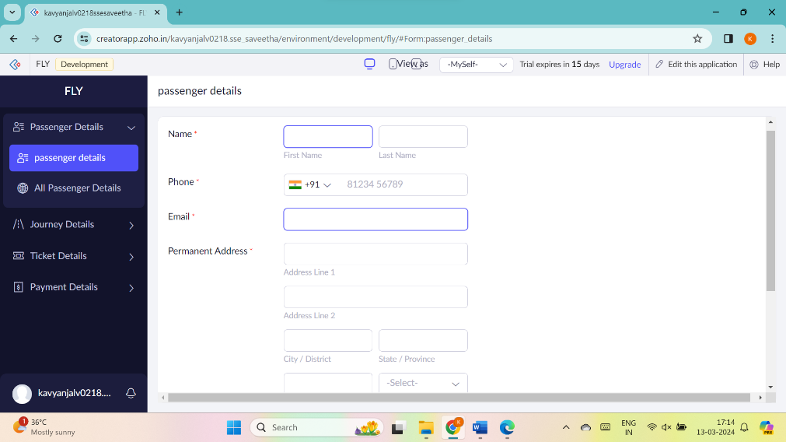

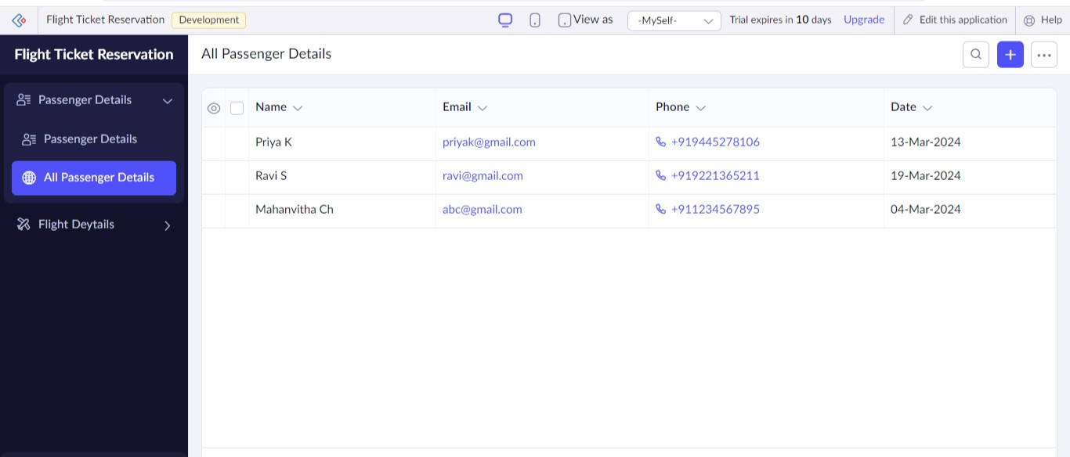

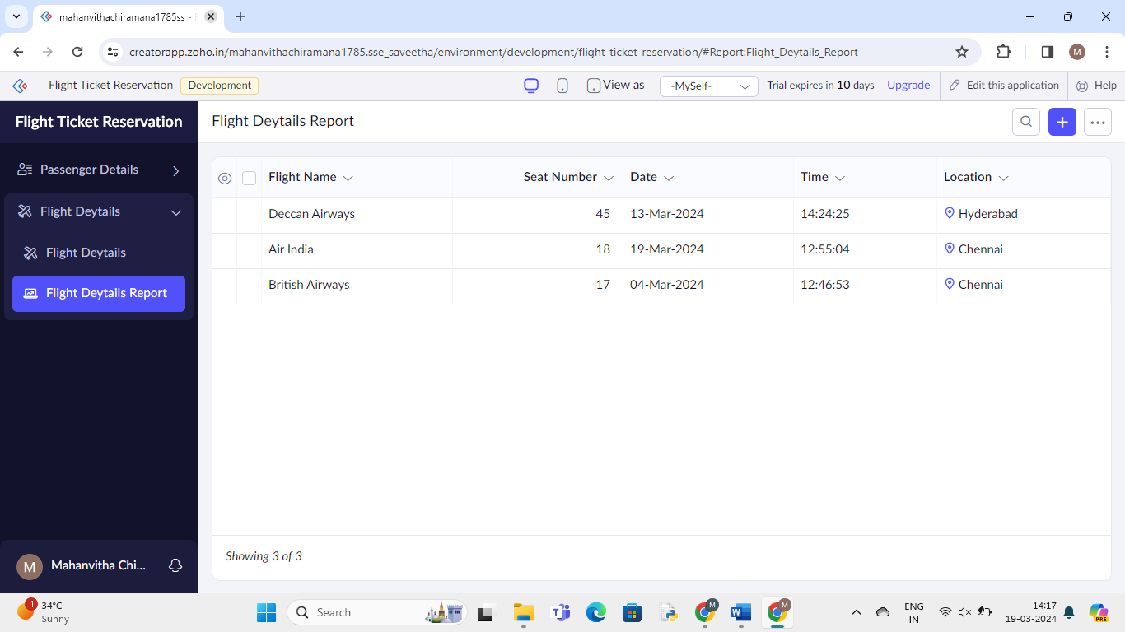

1. **Property buying and rental process**

Step -1: Go to Zoho.com and login



Step-2: Go to Creator



Step – 3: Create new application - scratch



Step- 4: Give application Name

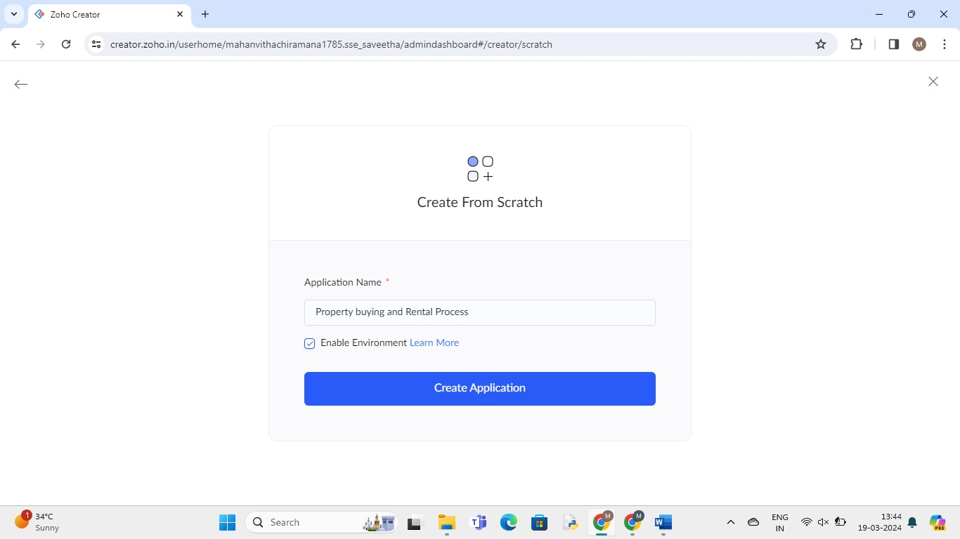

Step – 5: create new form and give name





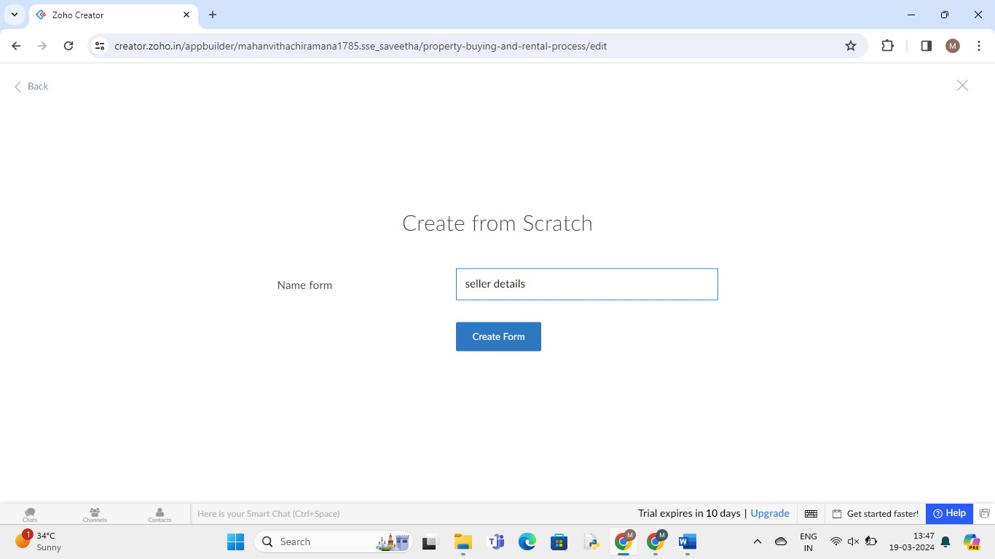

Step -6: Drag necessary fields



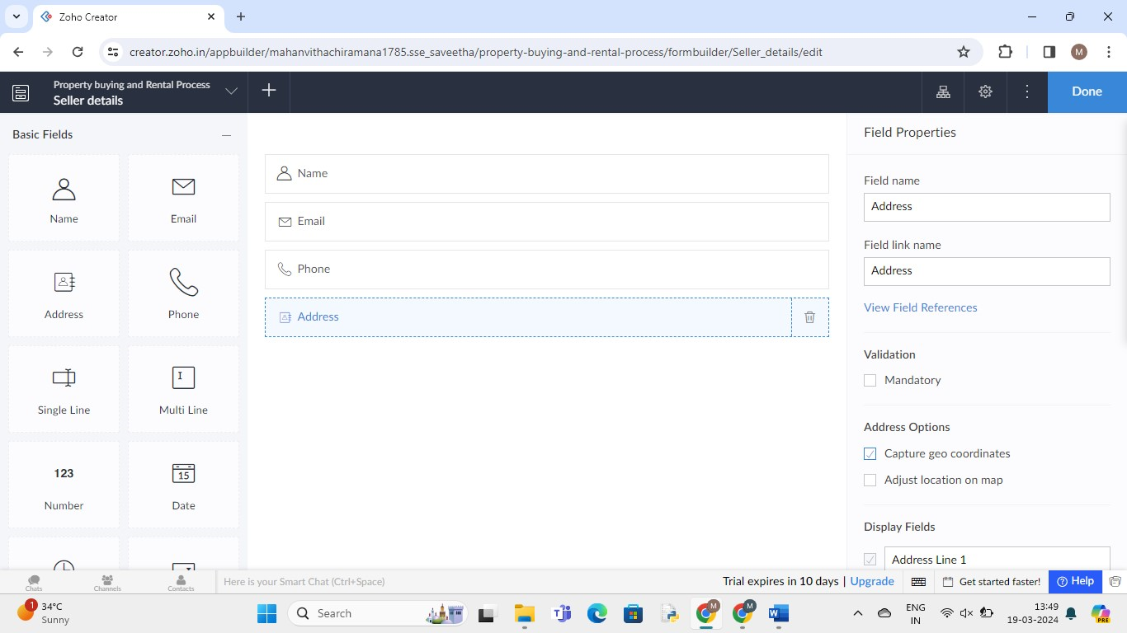

Step-7: Enter details



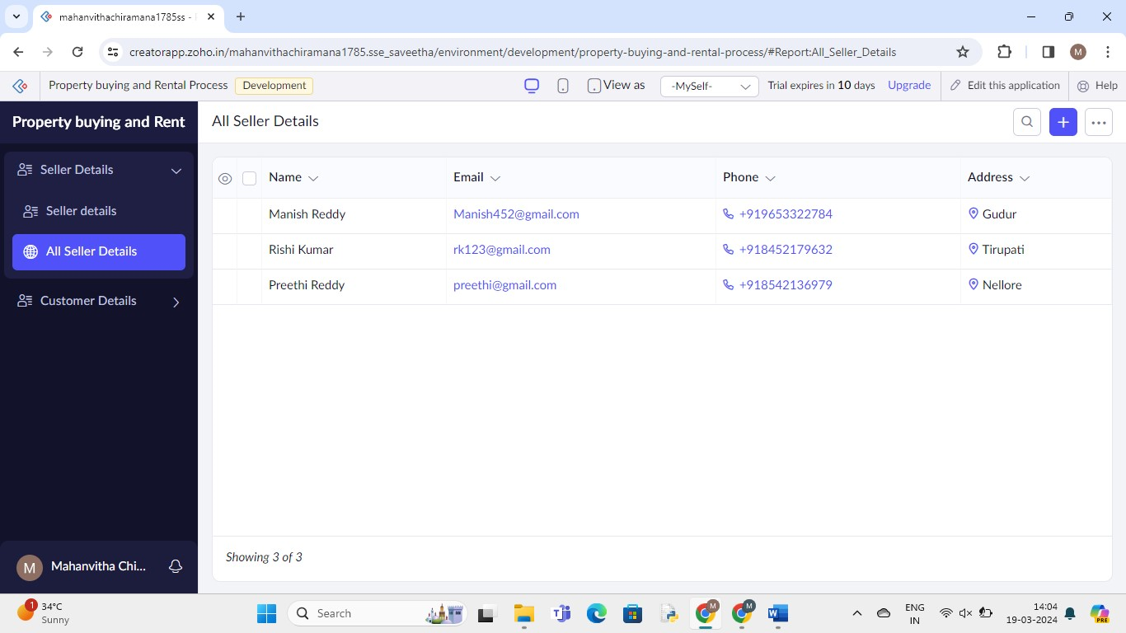

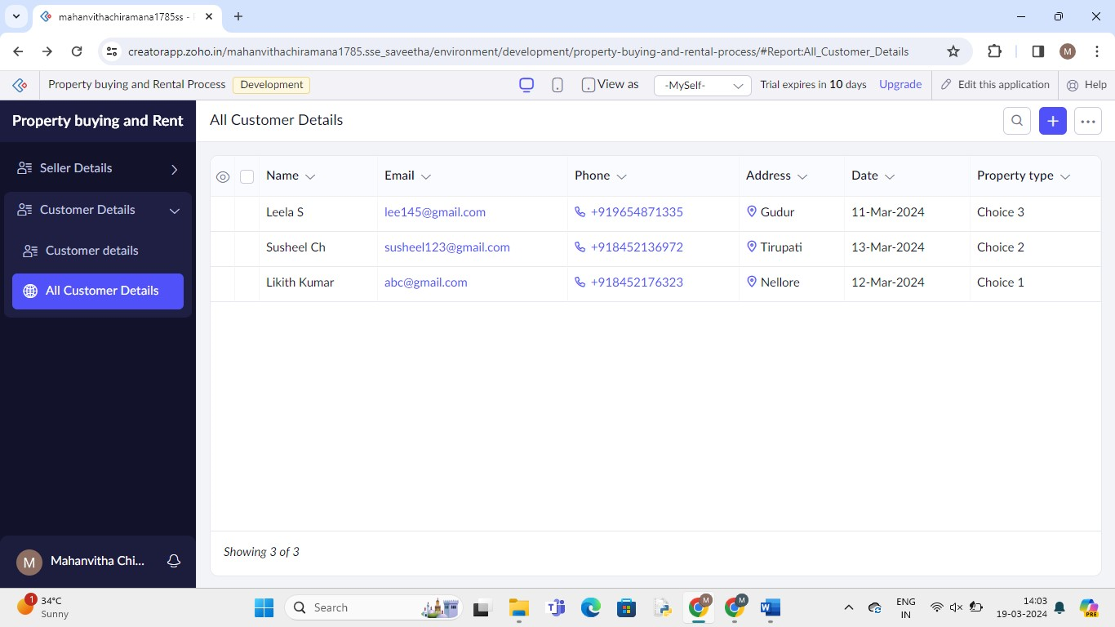

**3.Car Booking Reservation System**

Step -1: Go to Zoho.com and login



Step-2: Go to Creator



Step – 3: Create new application - scratch



Step- 4: Give application Name

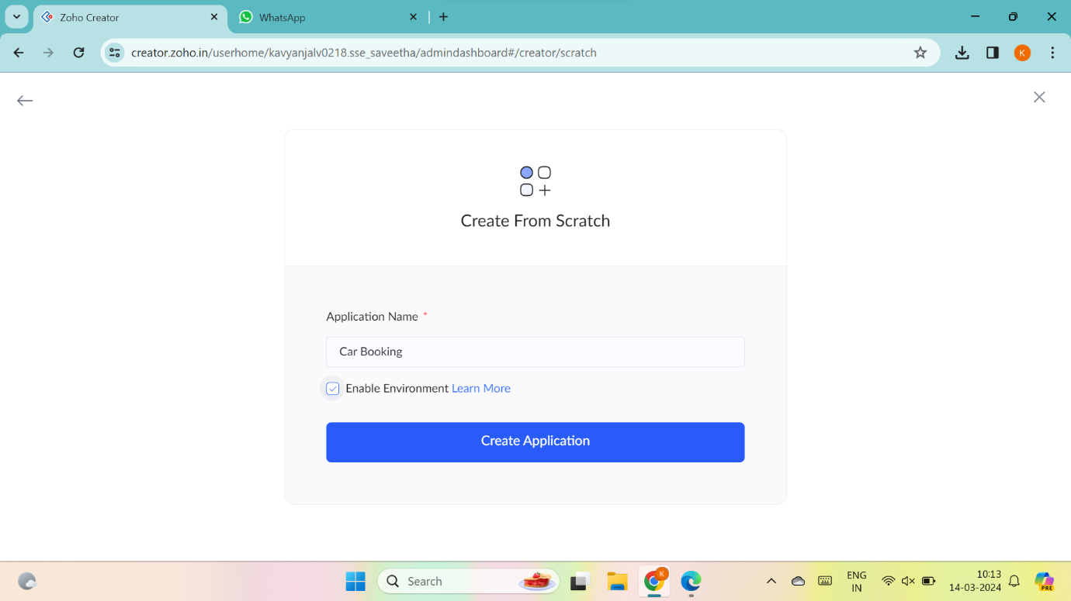

Step – 5: create new form and give name





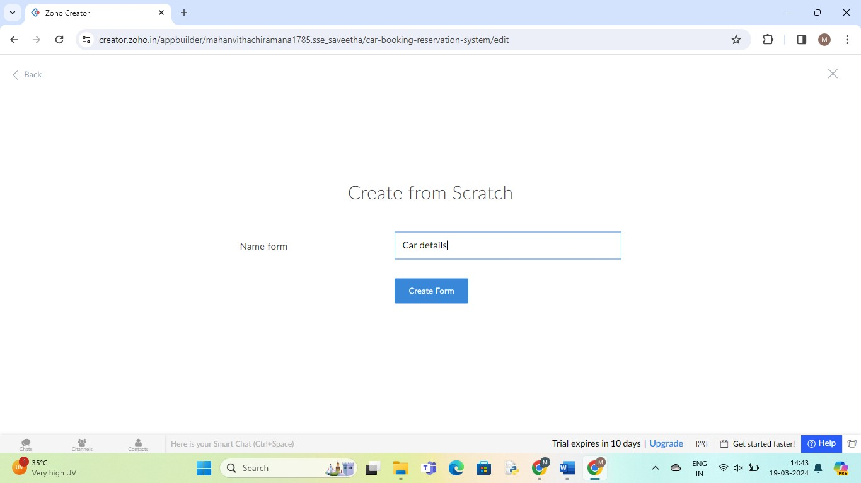

Step -6: Drag necessary fields

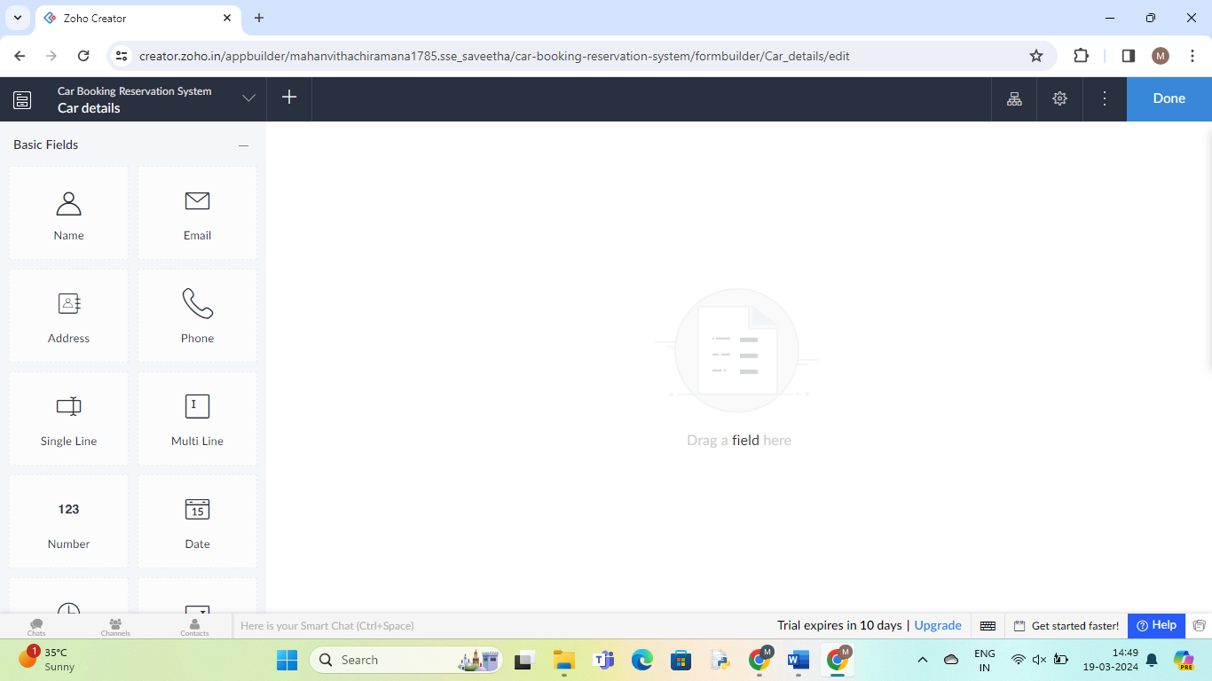

Step – 7: Enter details

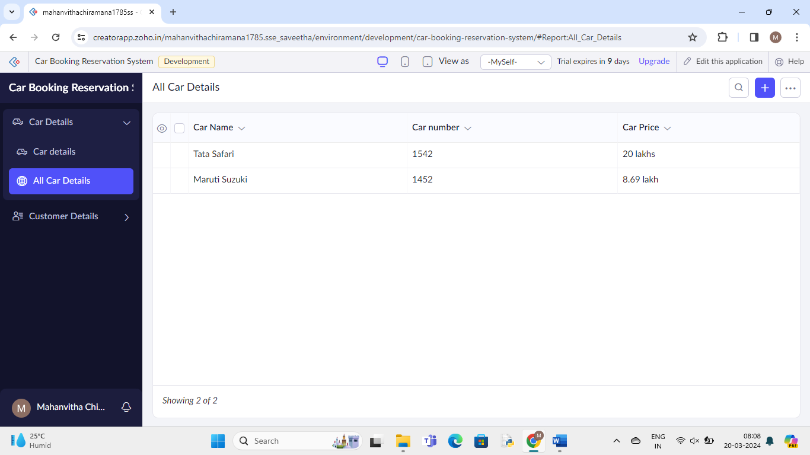

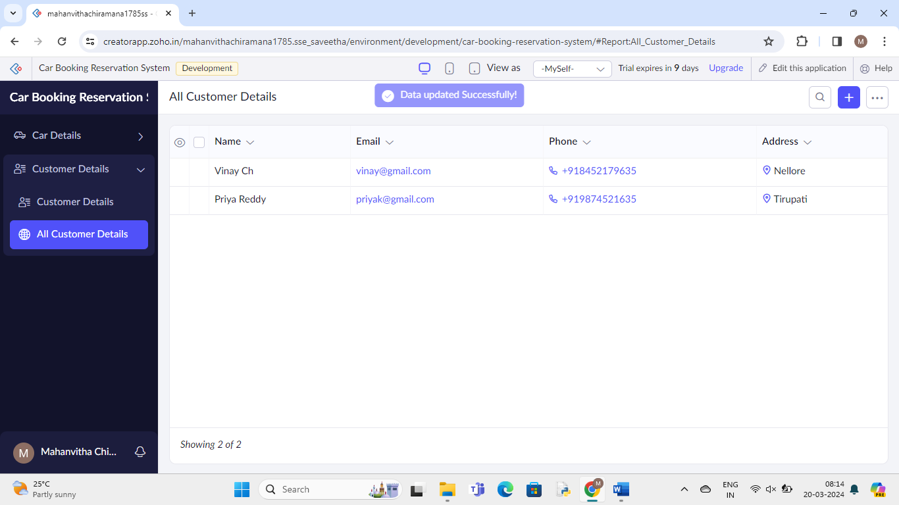

**4.Library Book Reservation System**

Step -1: Go to Zoho.com and login



Step-2: Go to Creator



Step – 3: Create new application - scratch



Step- 4: Give application Name

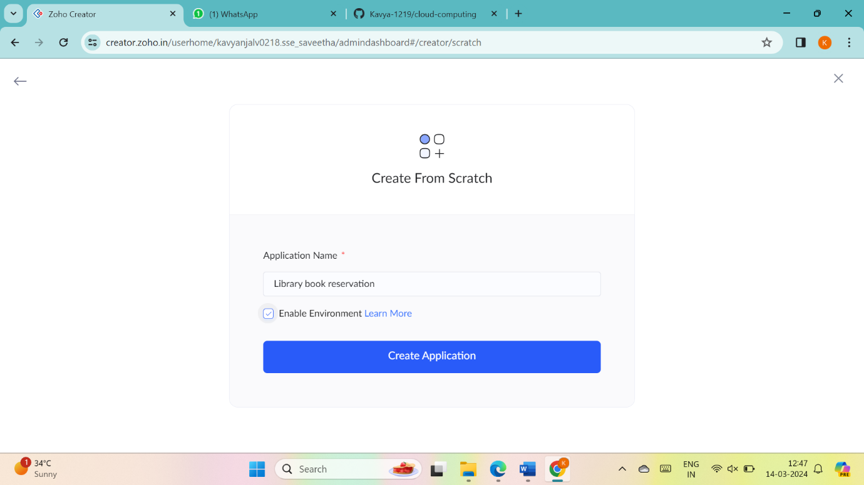

Step – 5: create new form and give name





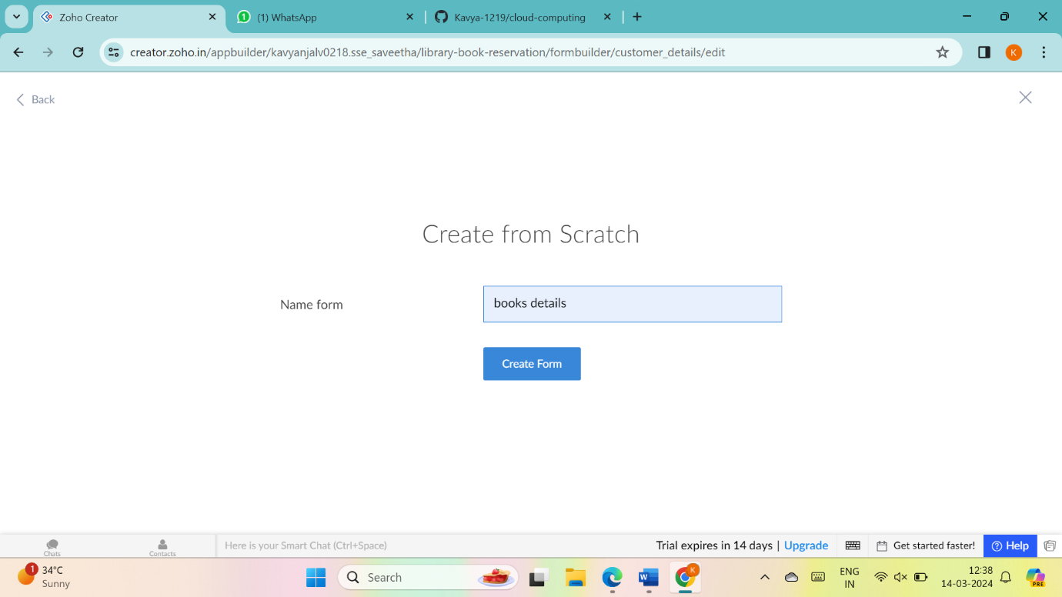

Step -6: Drag necessary fields



Step – 7: Enter details

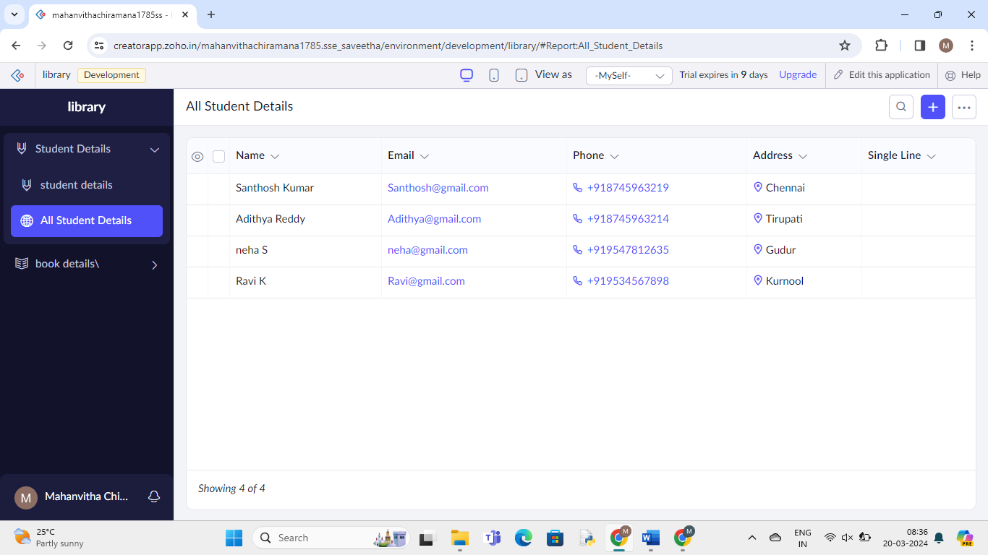

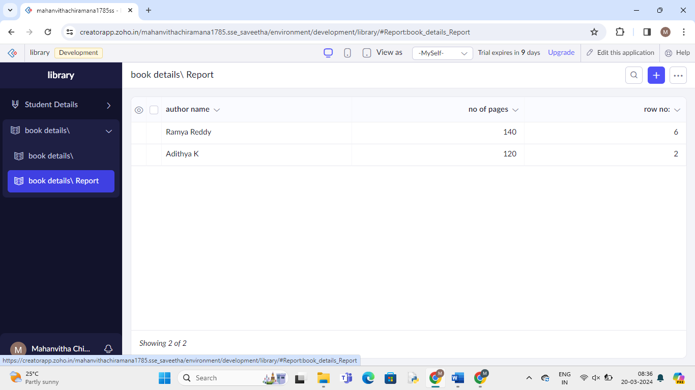

**5. Mark Sheet Processing System**

1.Go to Zoho.com and login/signup

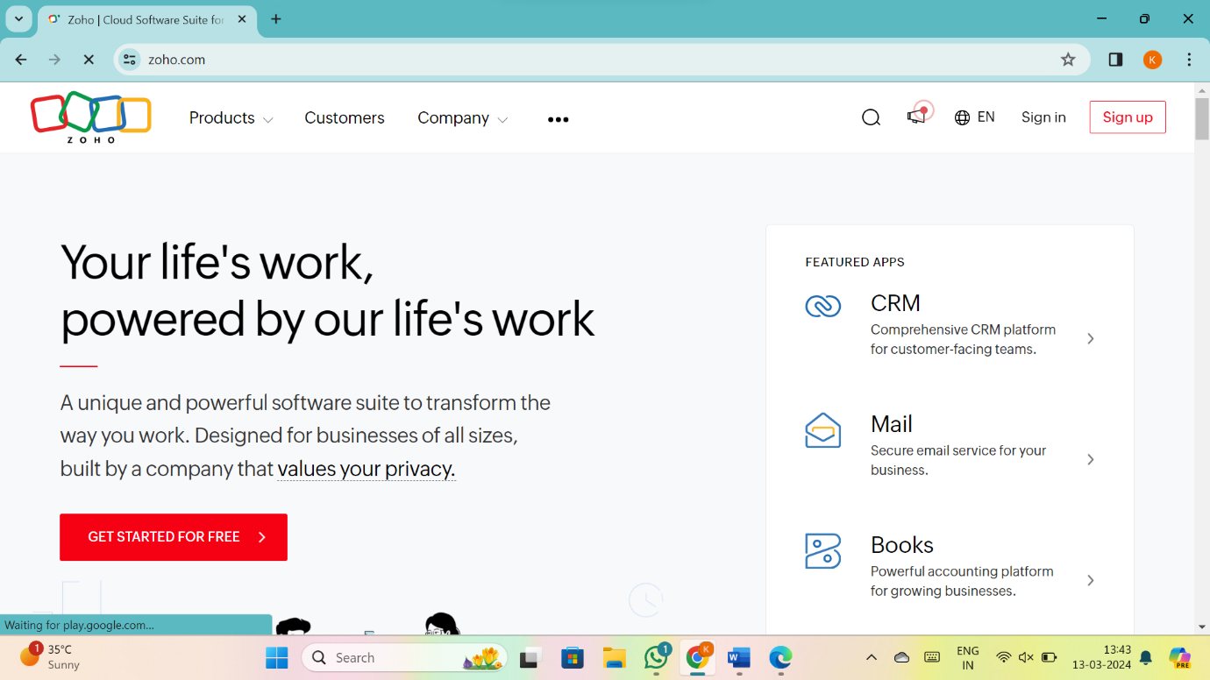

2.Go to Creator

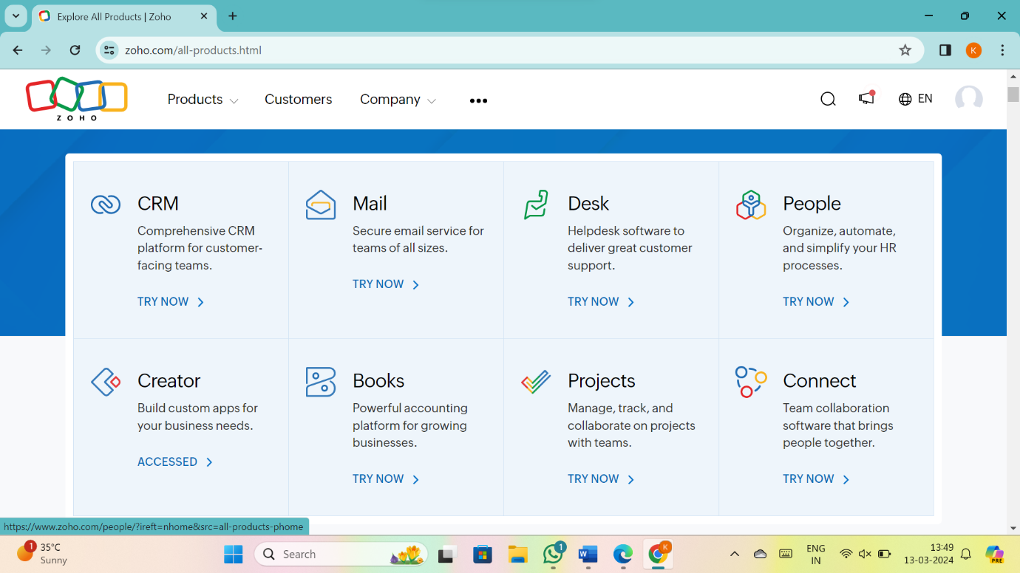

3. CREATE NEW APPLICATION

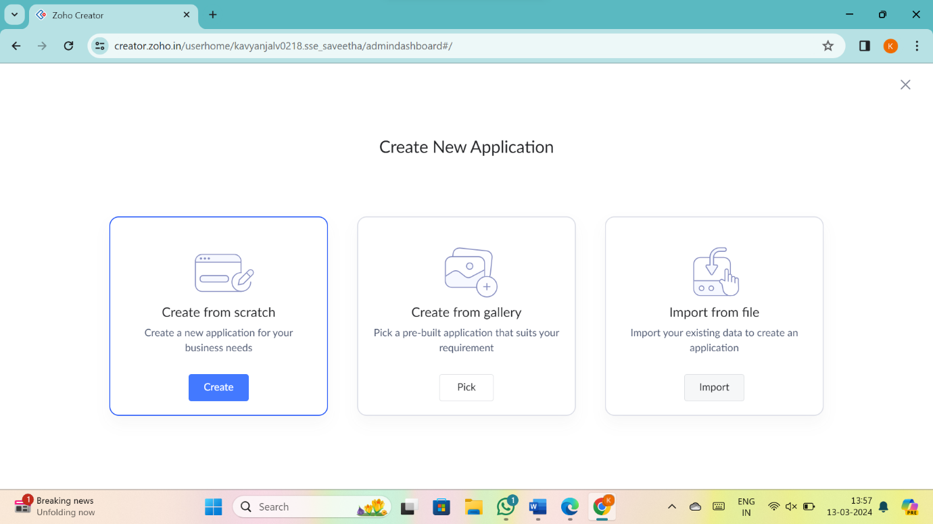

4.Give Application Name

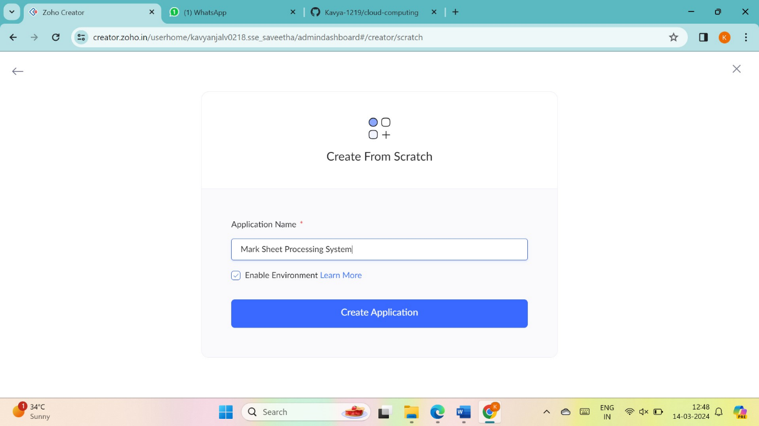

5.Create New Form

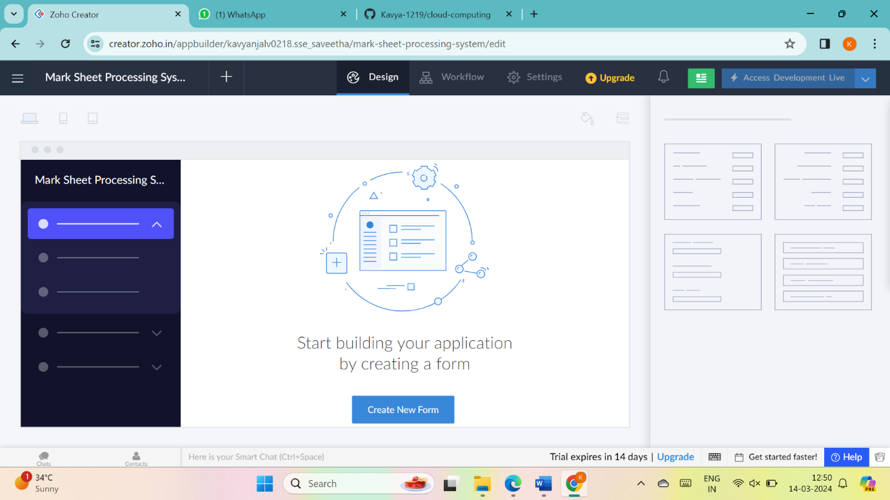

6.Select Form and give name

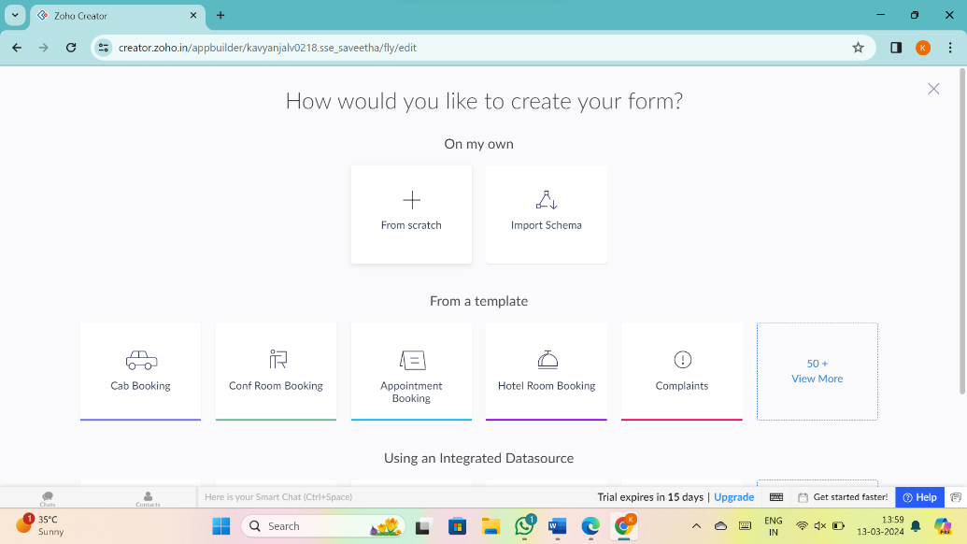

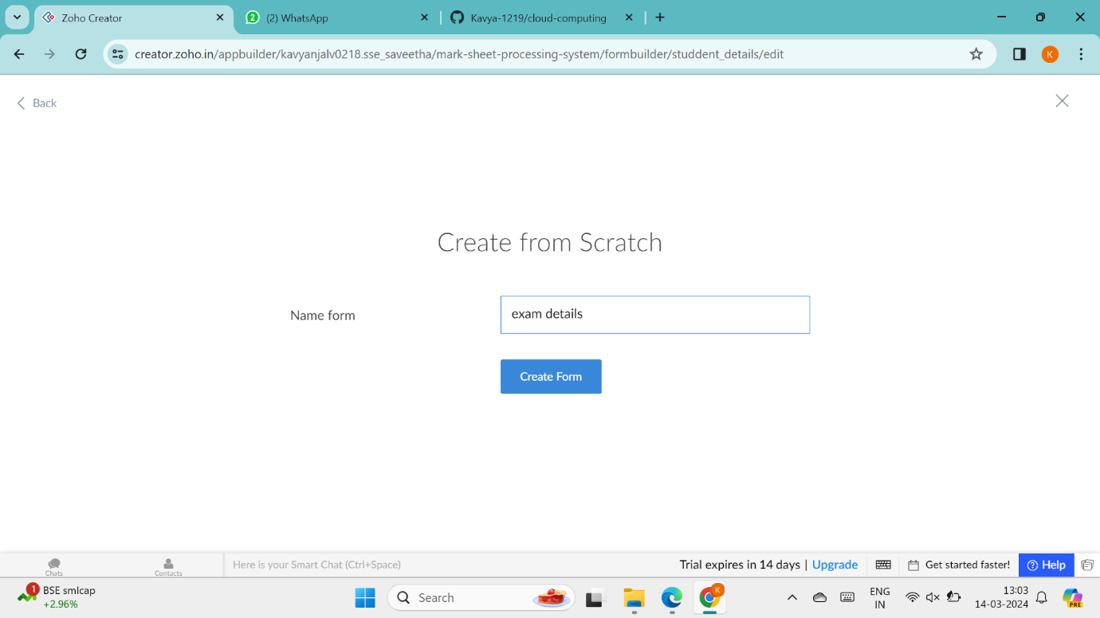

7.Drag necessary fields

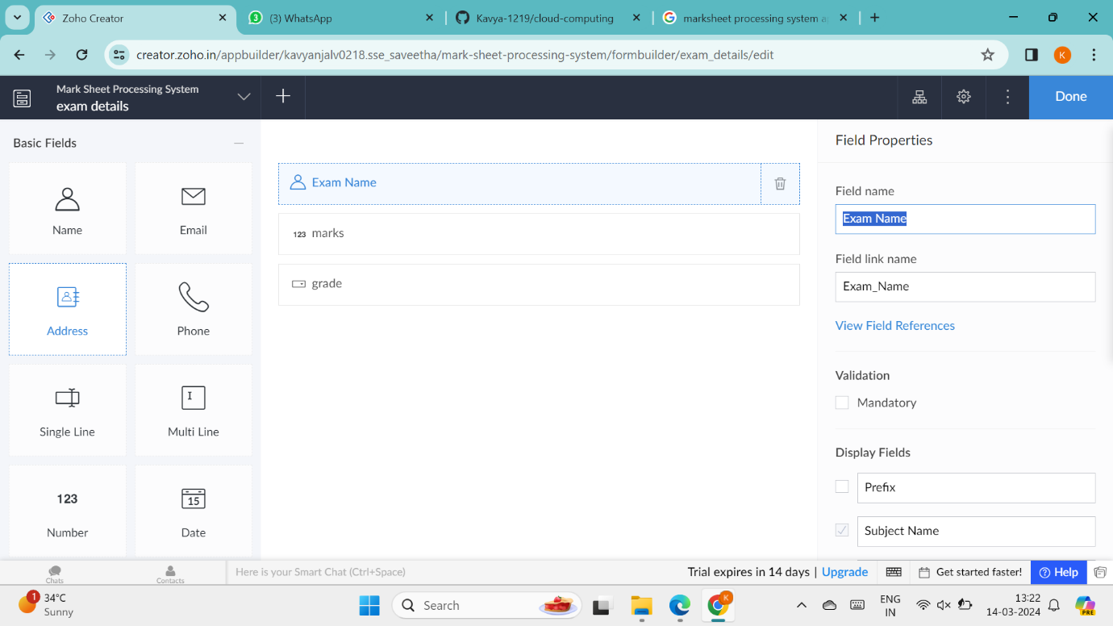

8.create new forms if necessary

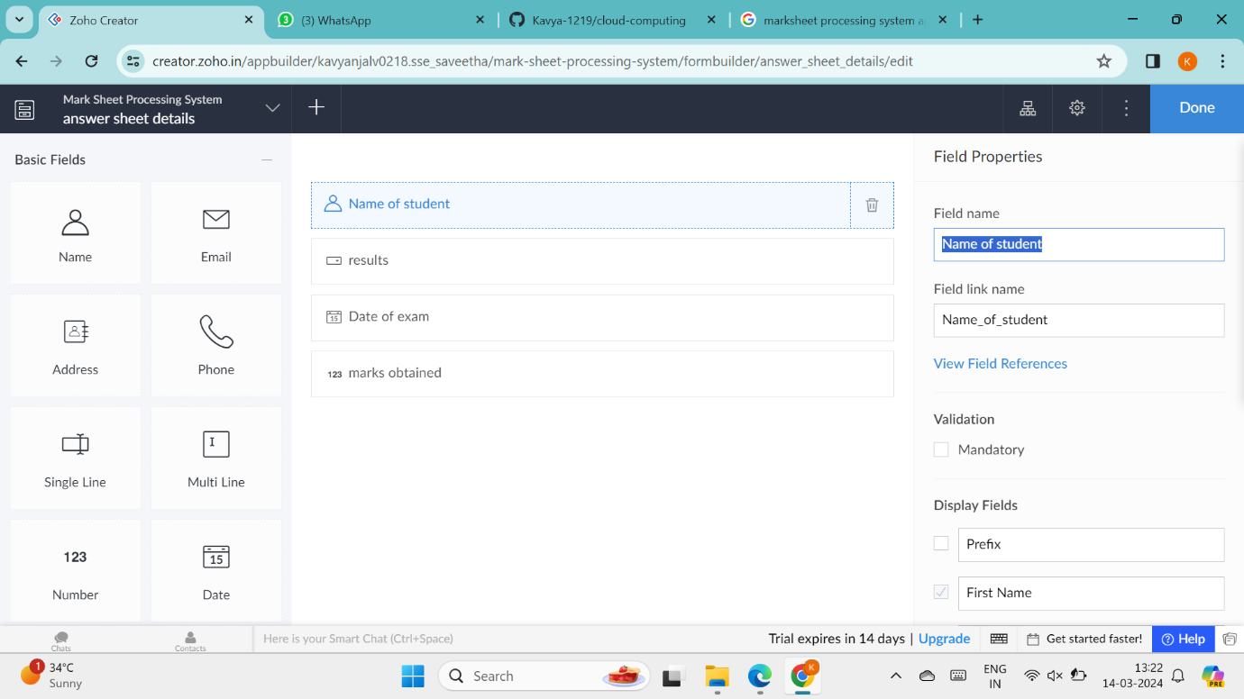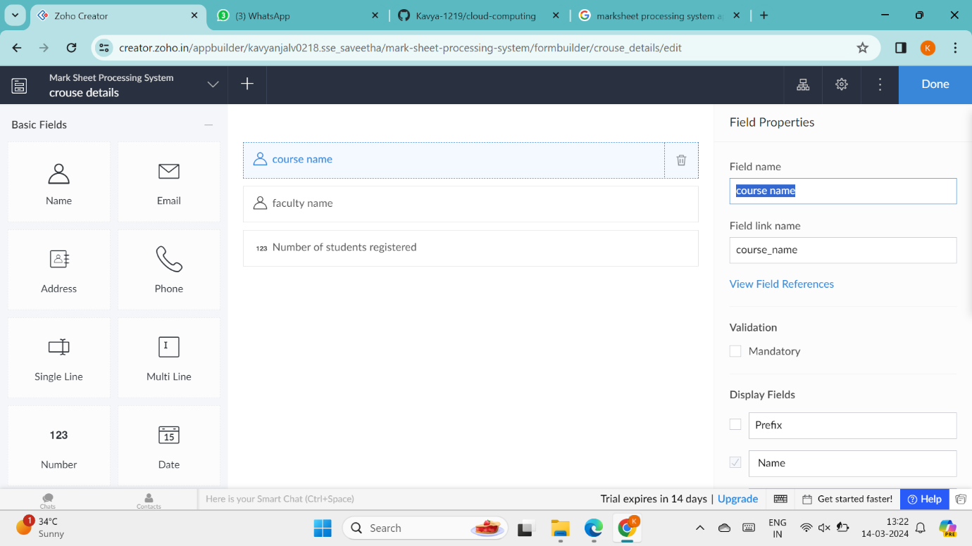

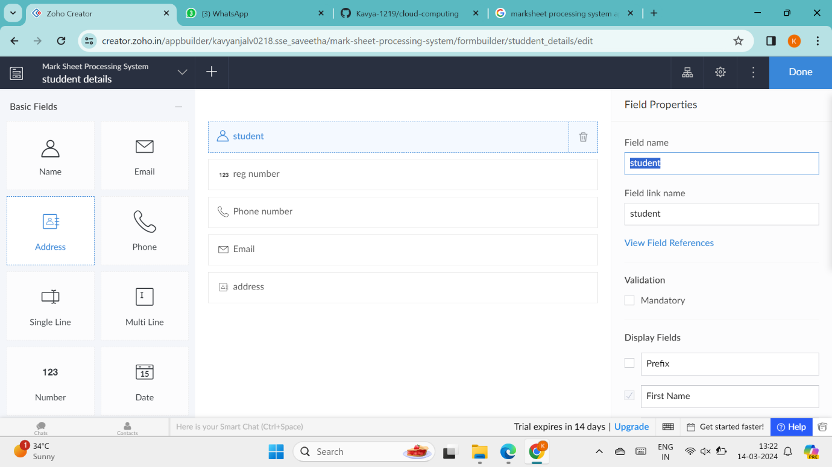

9.the software has been created

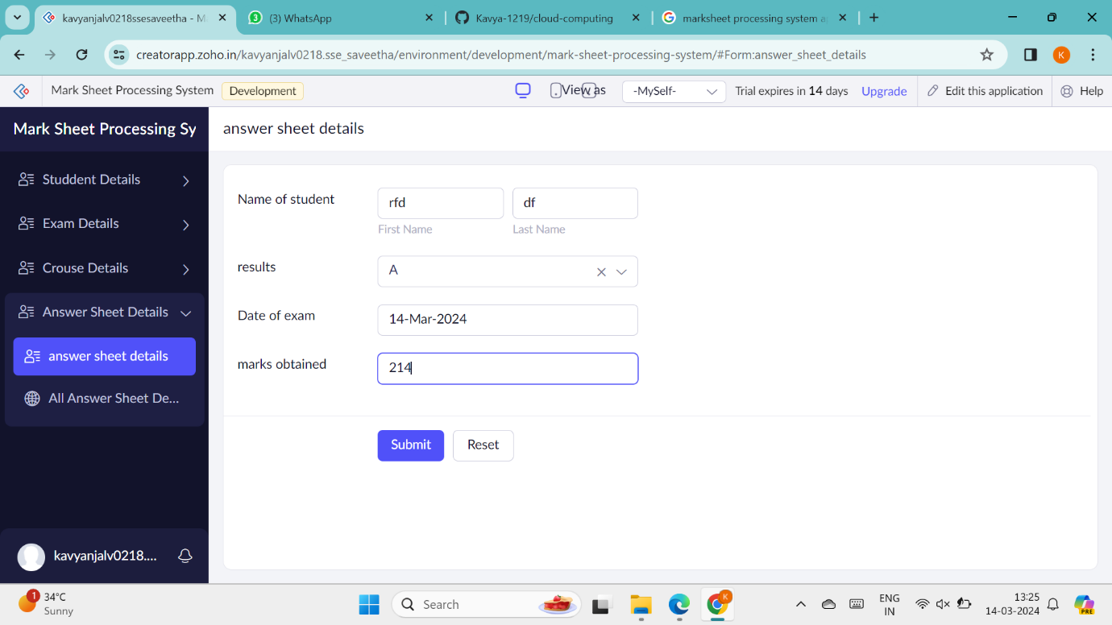

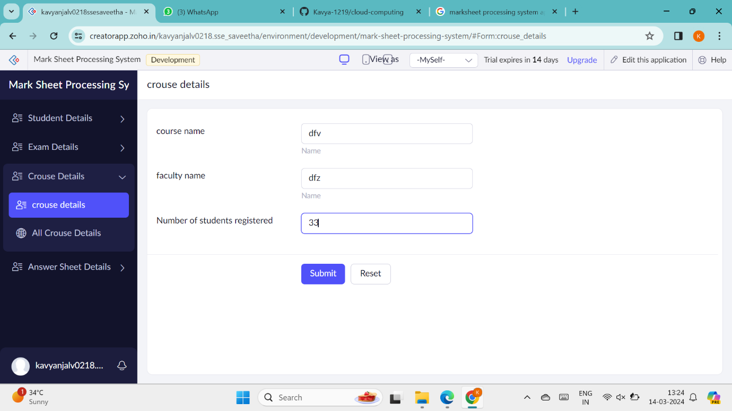

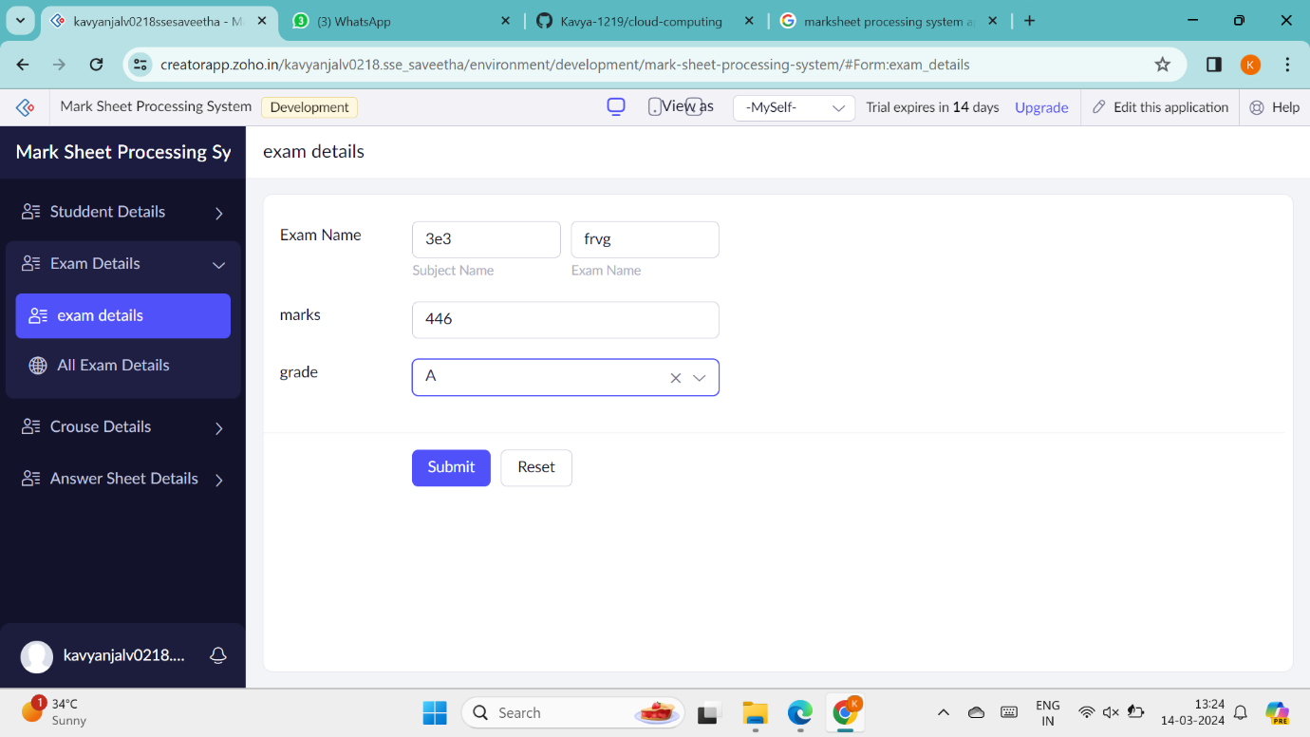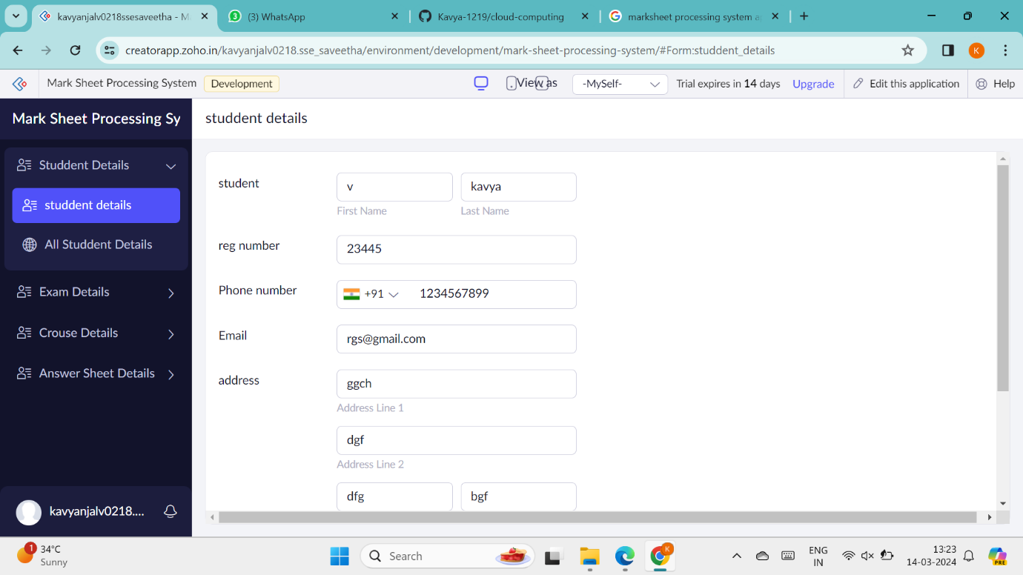

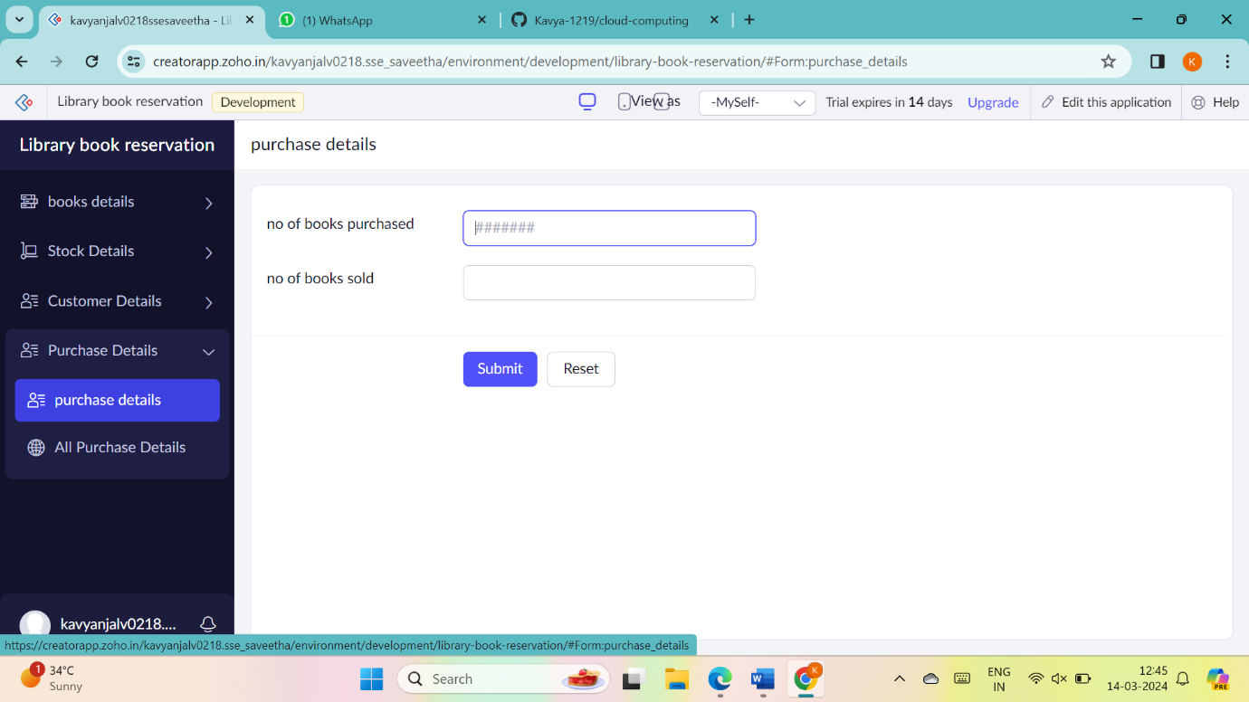

**6. Payroll processing system**

1.Go to Zoho.com and login/signup



2.Go to Creator



3. CREATE NEW APPLICATION



4.Give Application Name



5.Create New Form



6.Select Form and give name



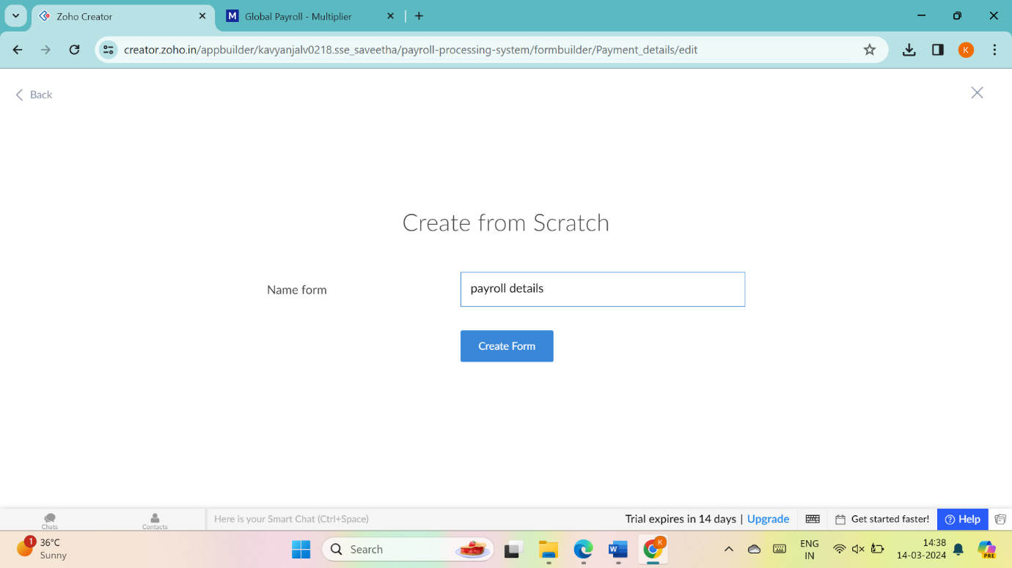

7.Drag necessary fields

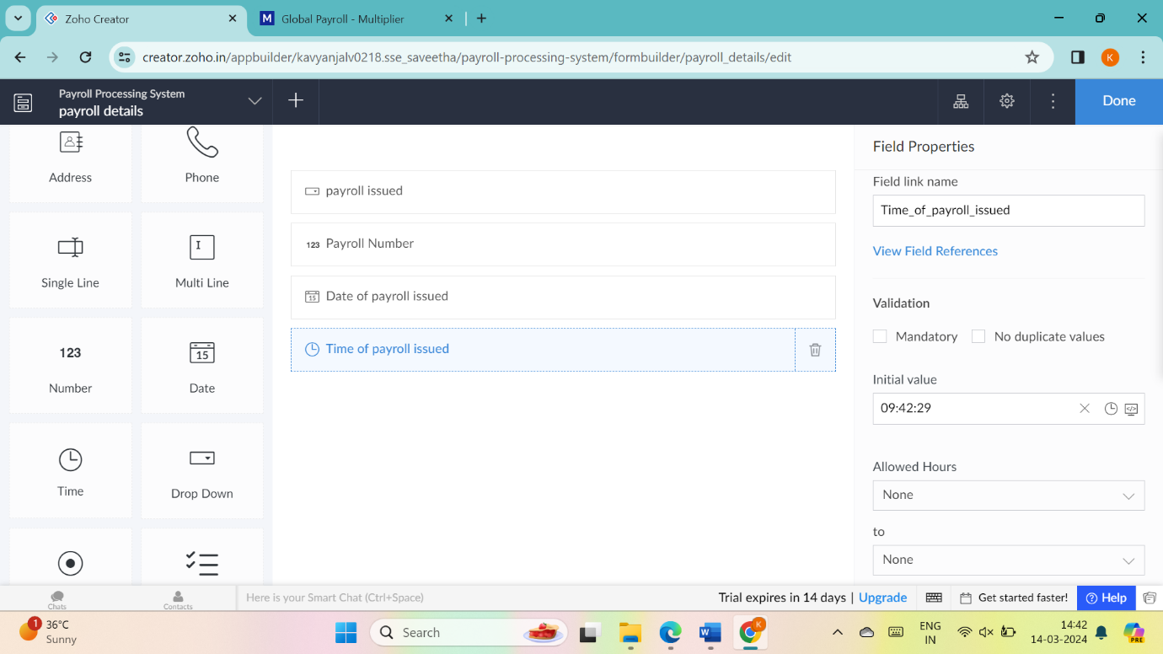

8.create new forms if necessary

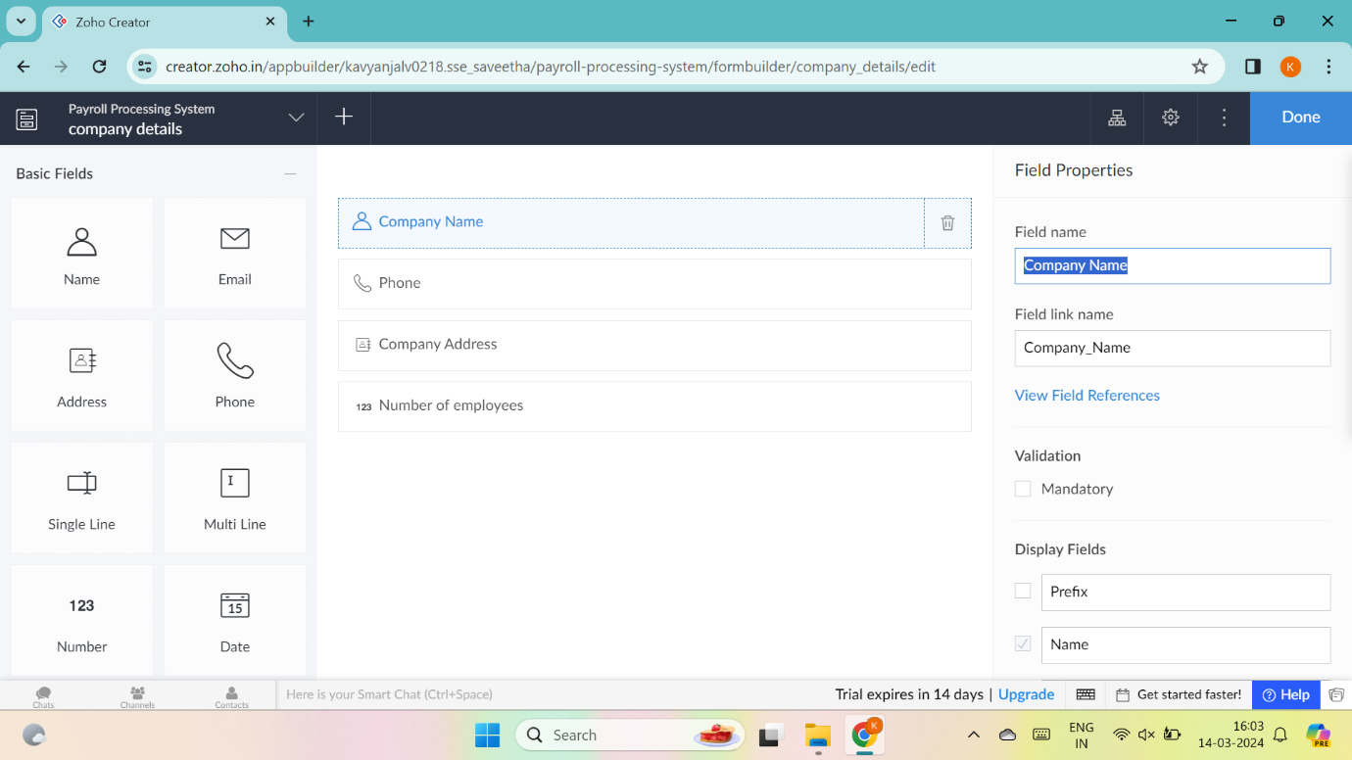

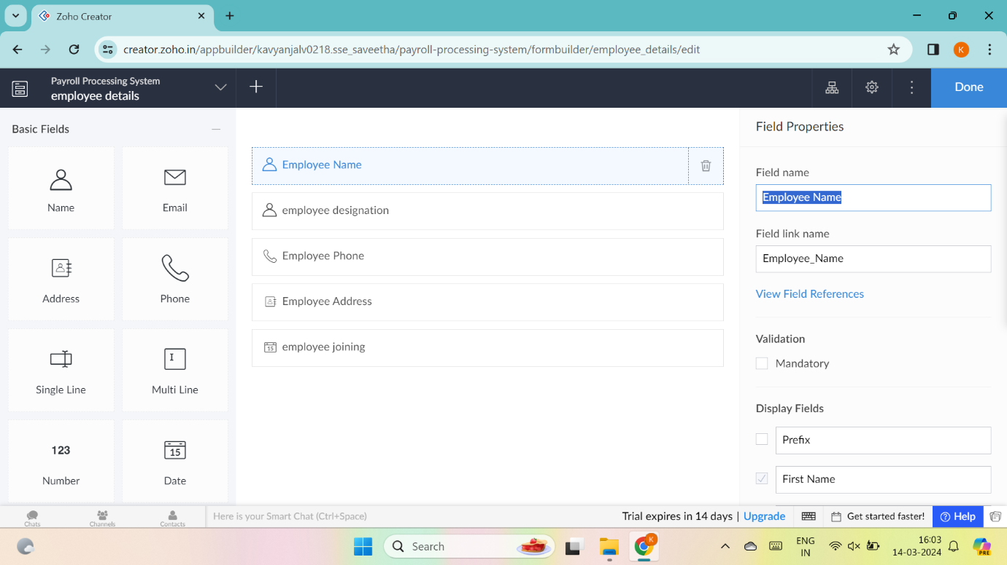

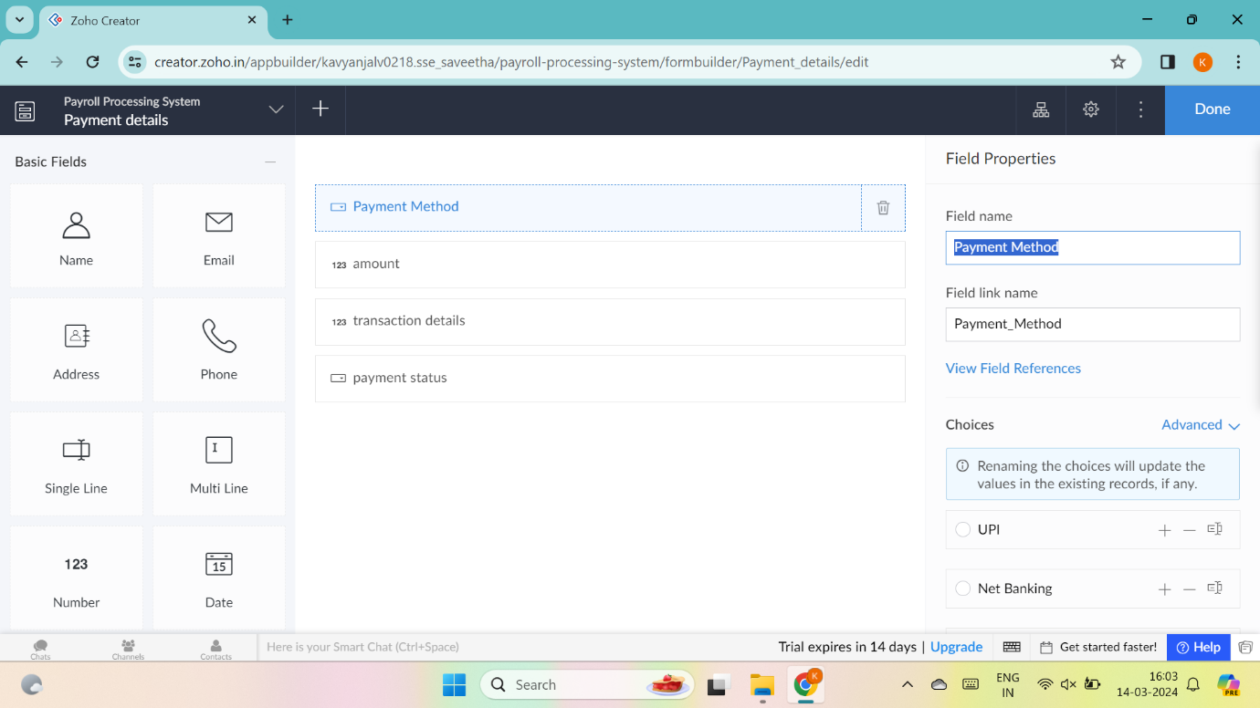

9. enter details

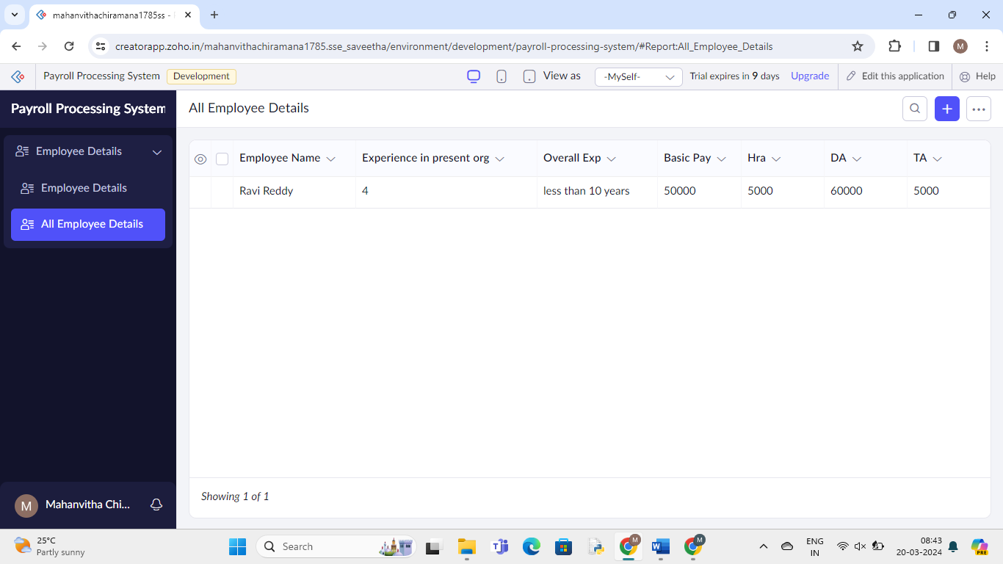

**7. Students Attendance System**

1.Go to Zoho.com and login/signup



2.Go to Creator



3. CREATE NEW APPLICATION



4.Give Application Name

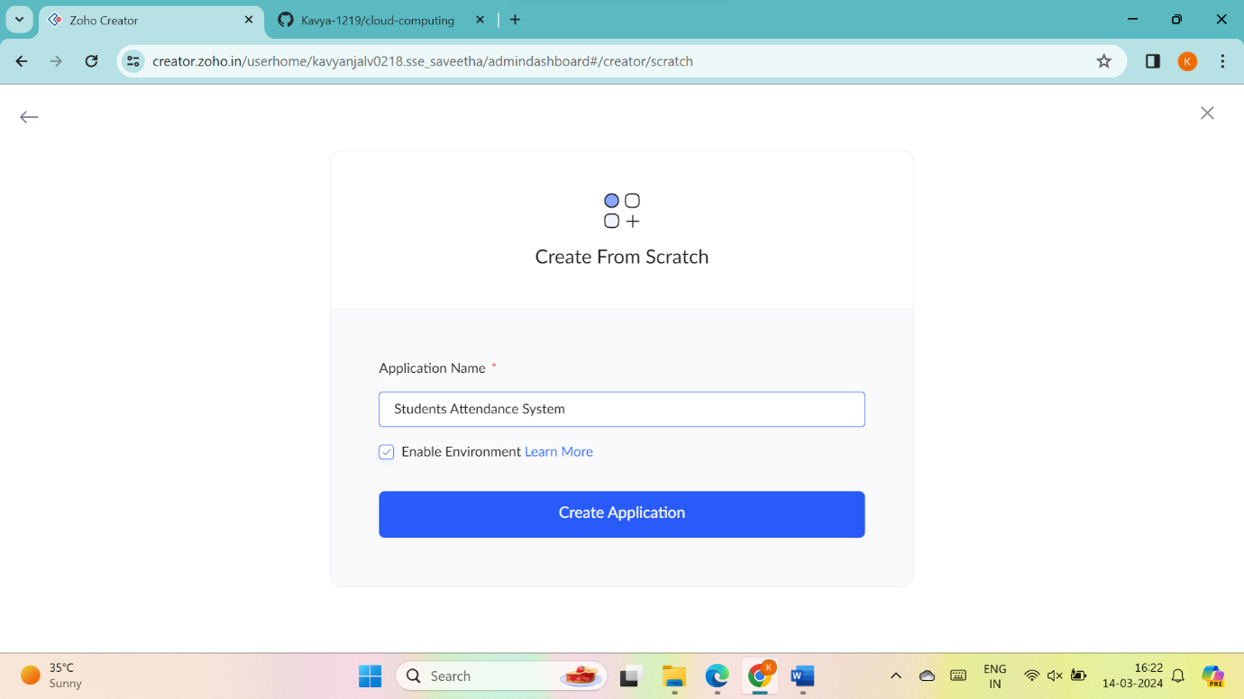

5.Create New Form



6.Select Form and give name



7.Drag necessary fields

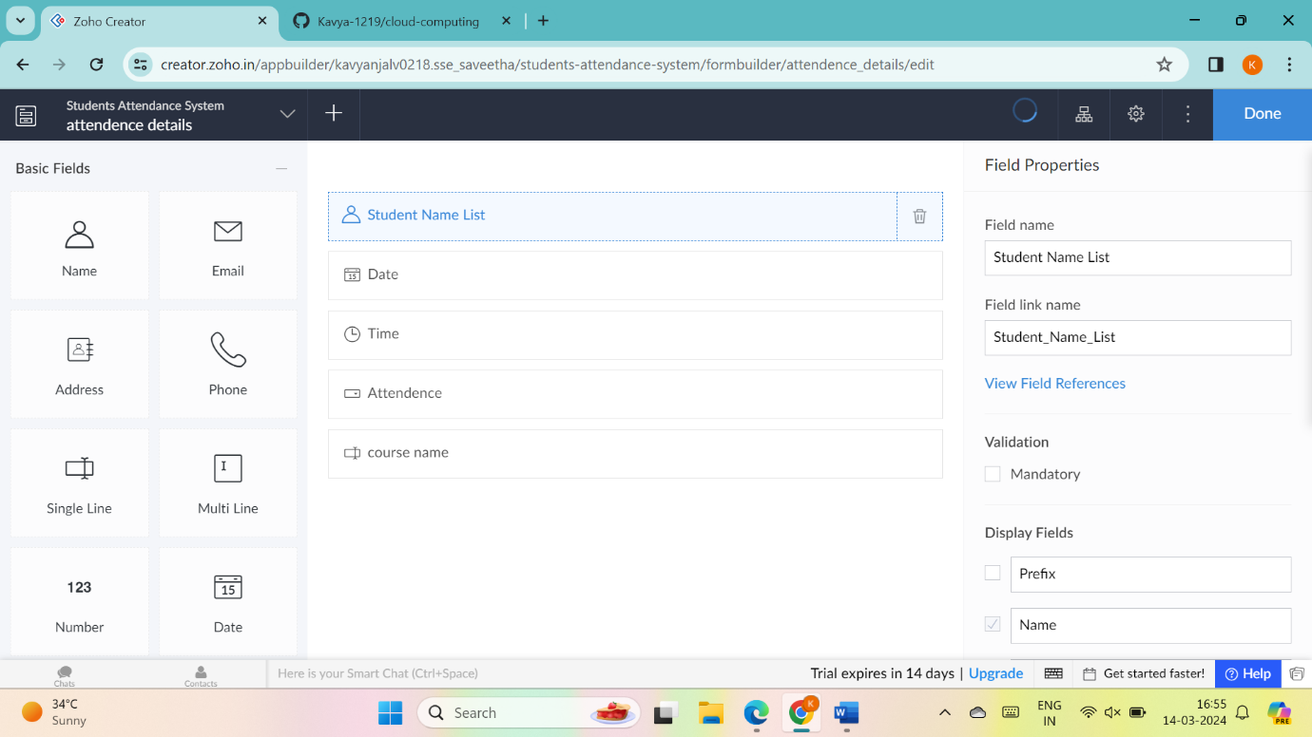

8.create new forms if necessary

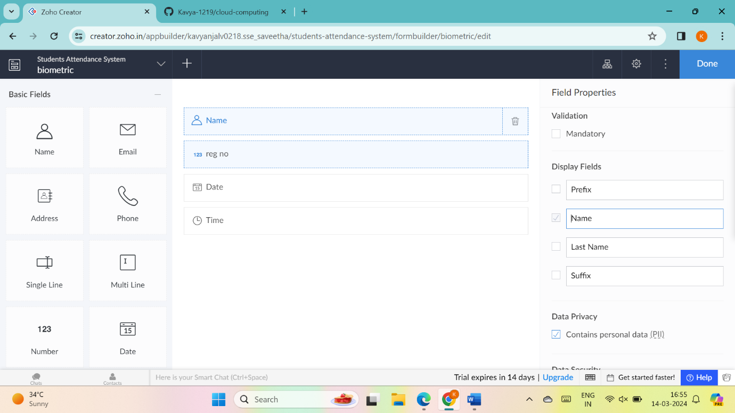

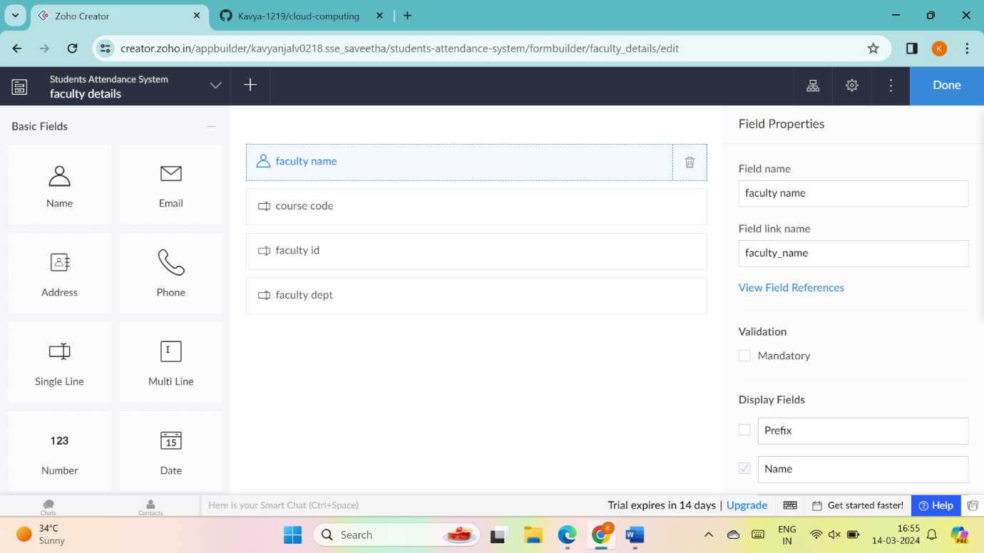

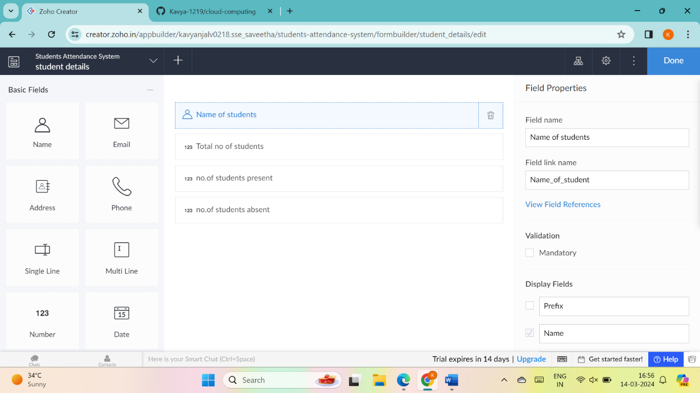

9.the software has been created

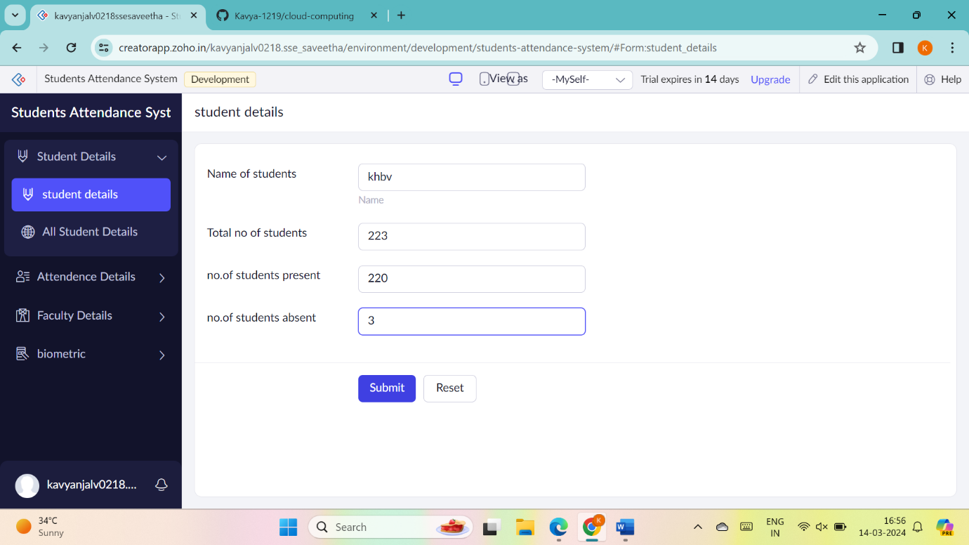

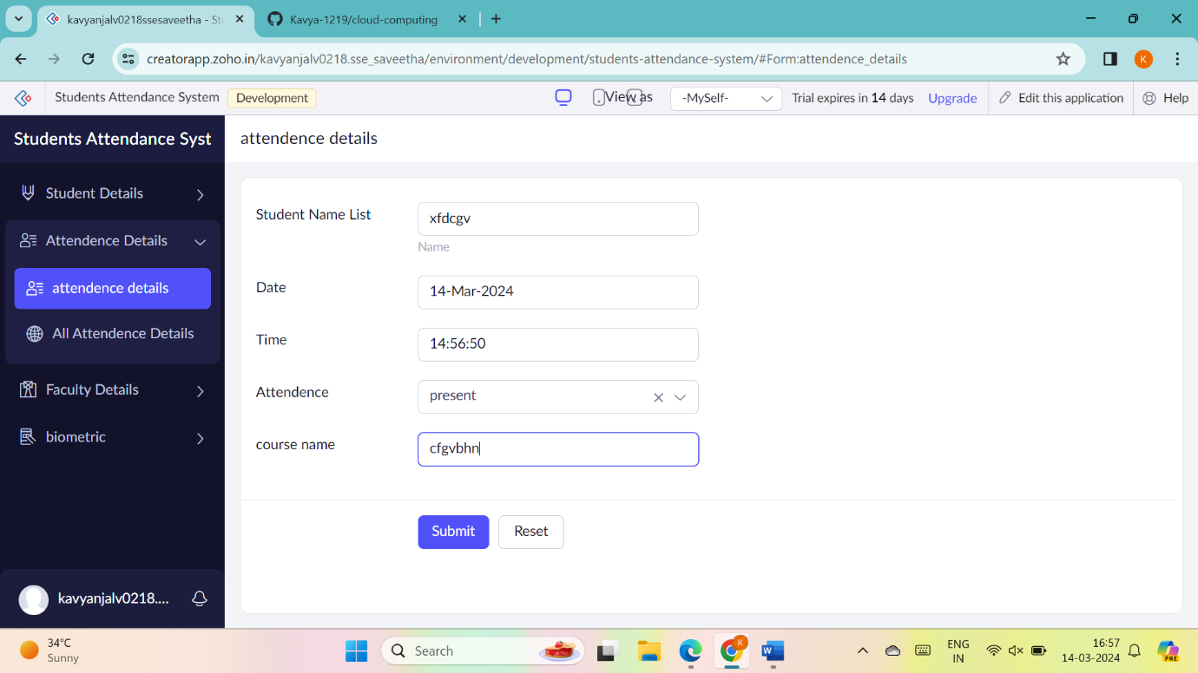

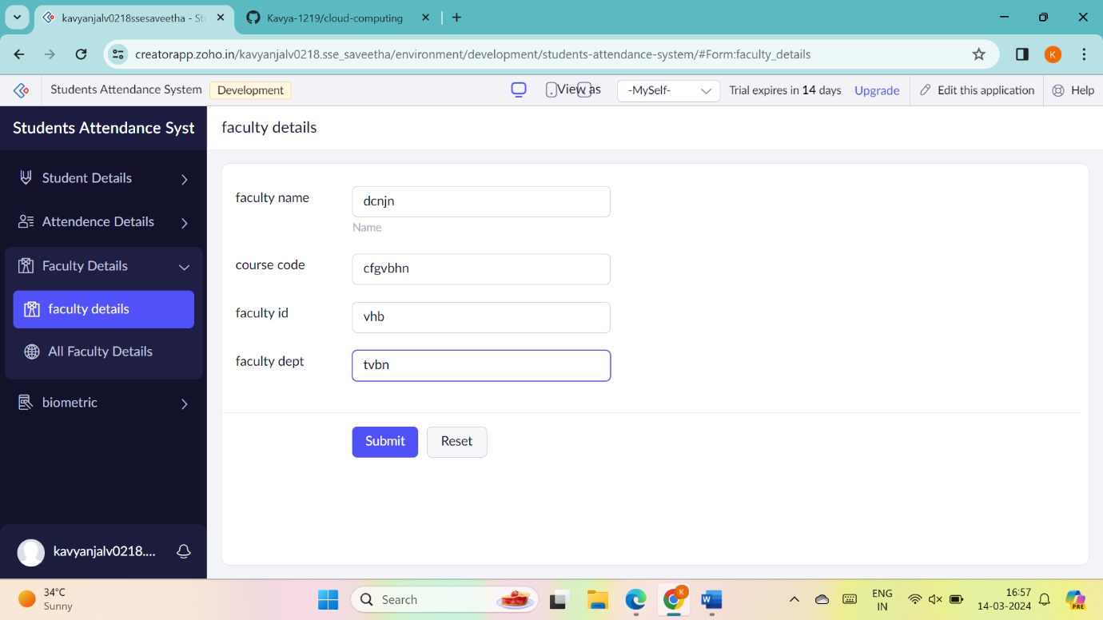

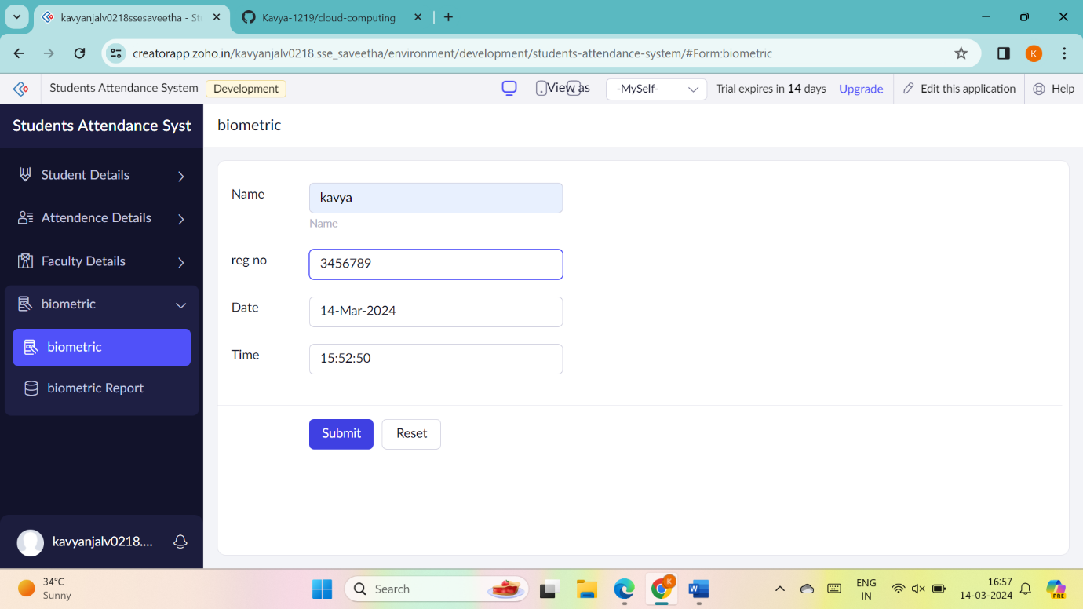

**8. student counselling system**

1.Go to Zoho.com and login/signup



2.Go to Creator



3. CREATE NEW APPLICATION



4.Give Application Name



5.Create New Form



6.Select Form and give name



7.Drag necessary fields

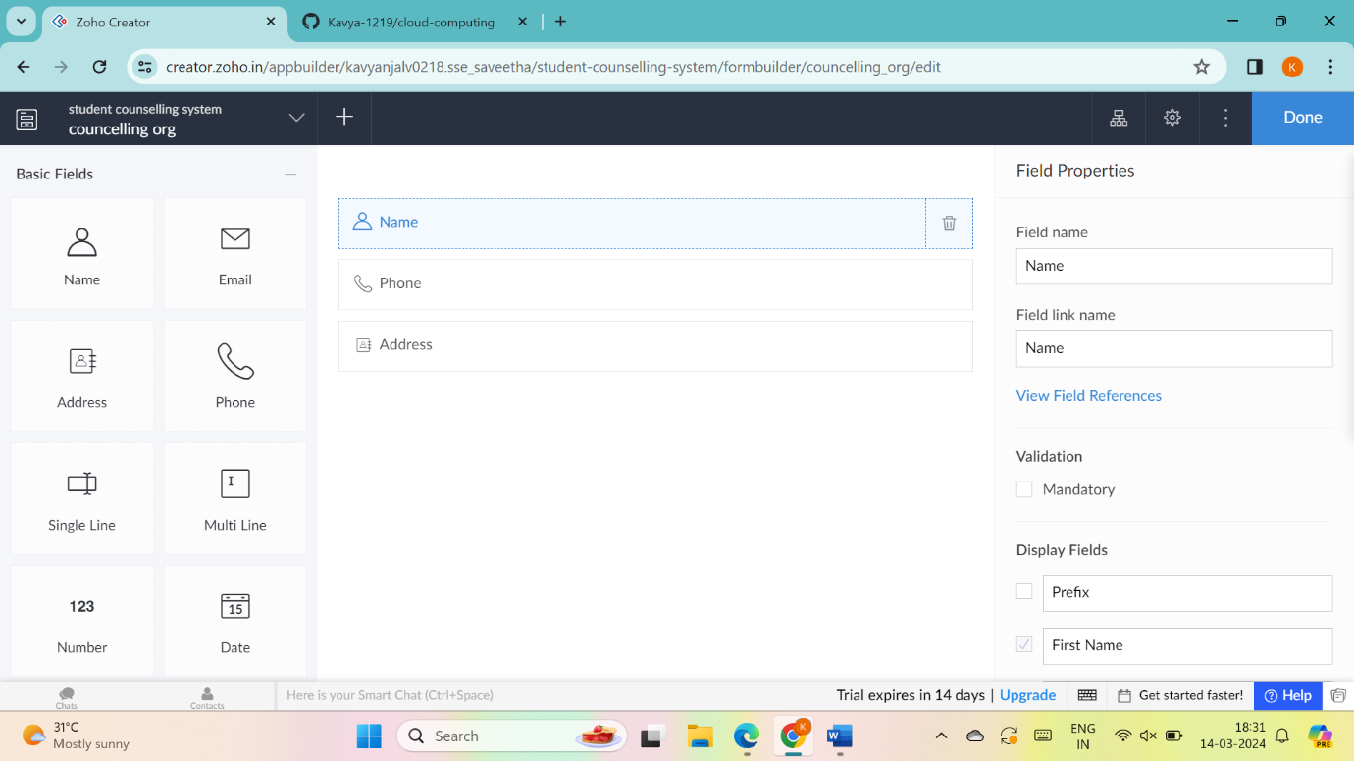

8.create new forms if necessary

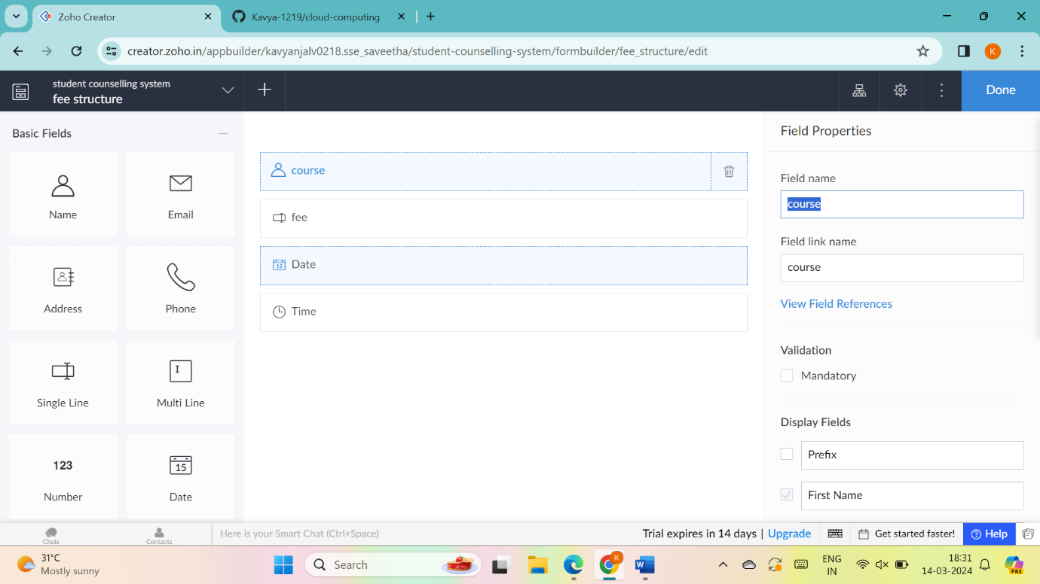

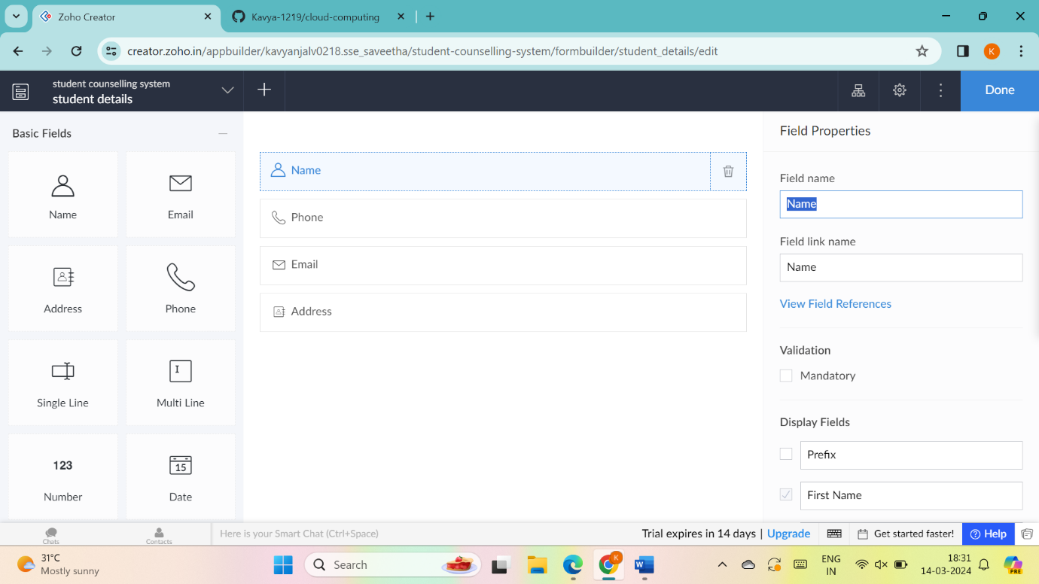

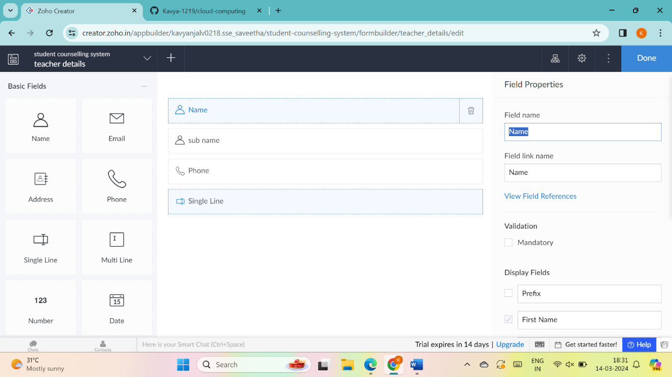

9.the software has been created

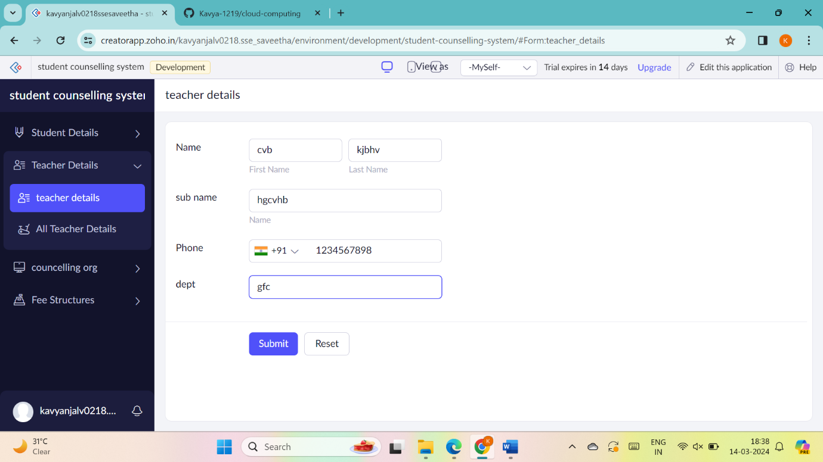

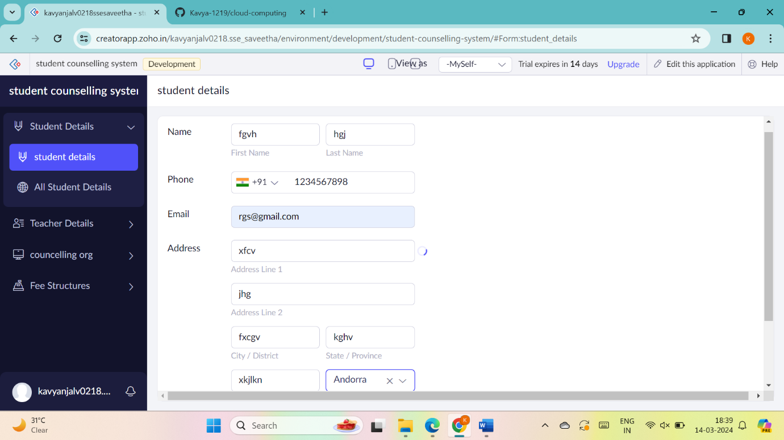

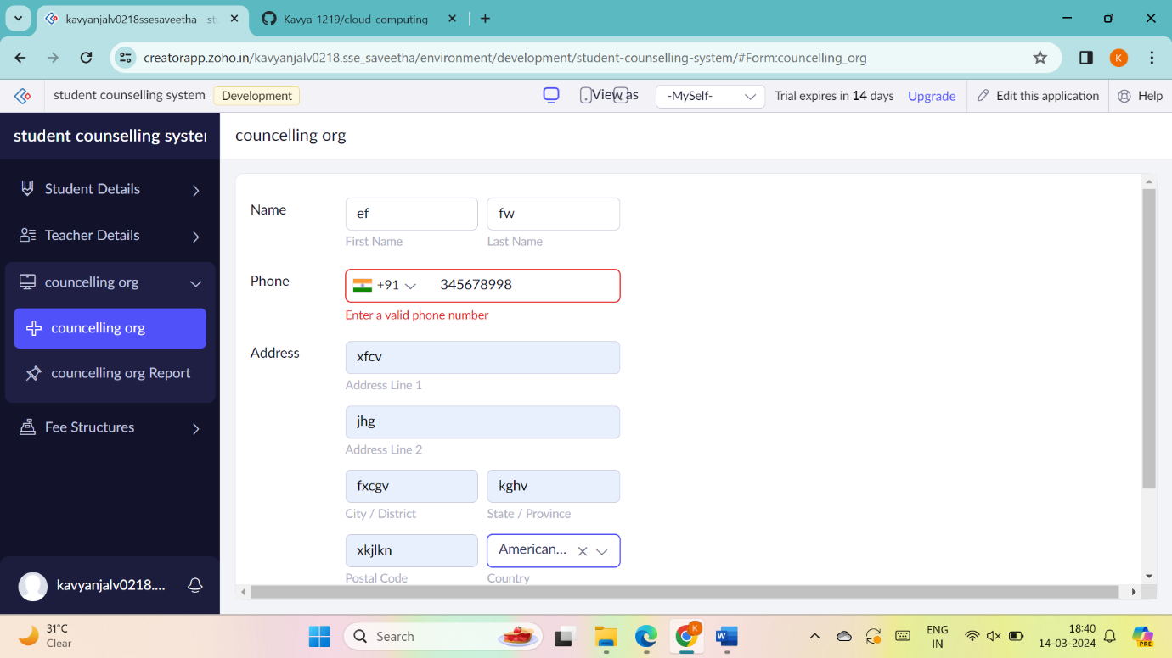

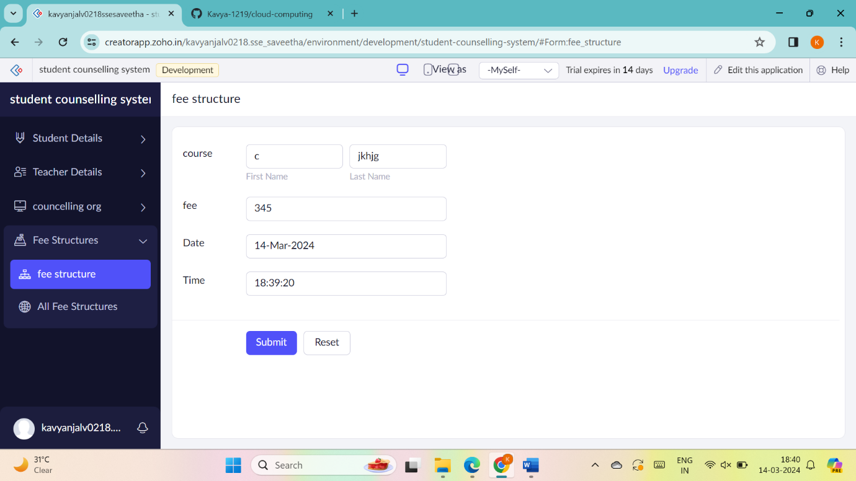

**9. Hospital information system**

1.Go to Zoho.com and login/signup



2.Go to Creator



3. CREATE NEW APPLICATION



4.Give Application Name and create new form



5. Select Form and give name



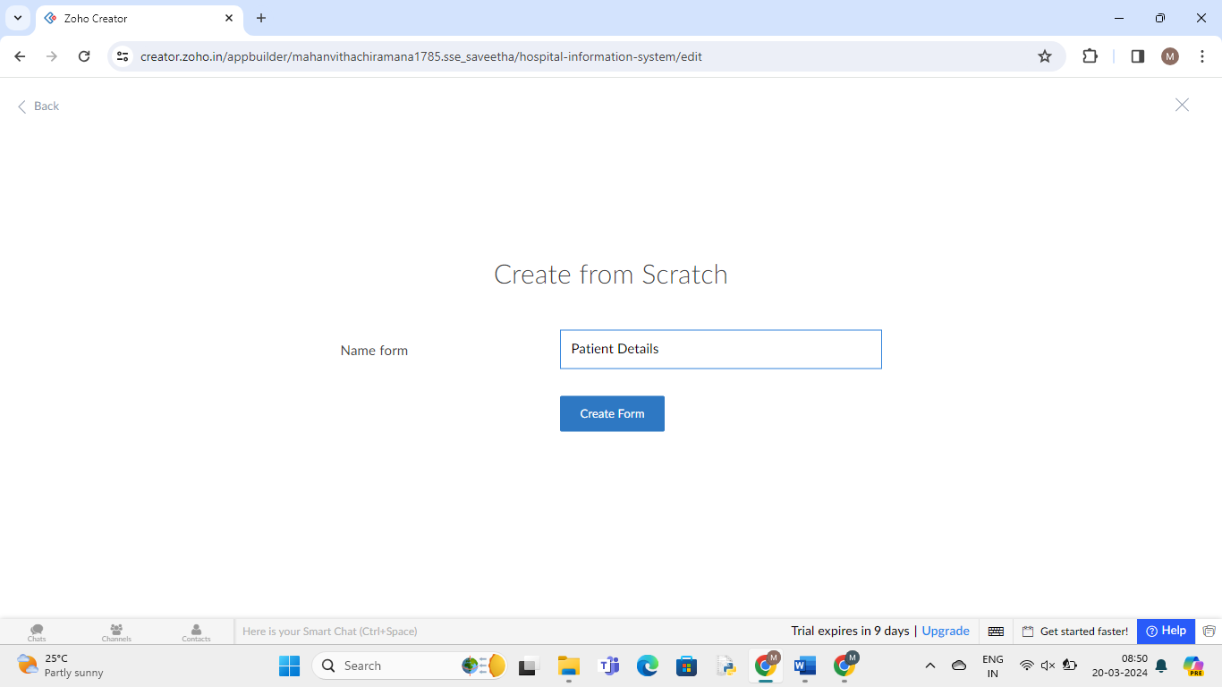

6.Drag necessary fields and enter details

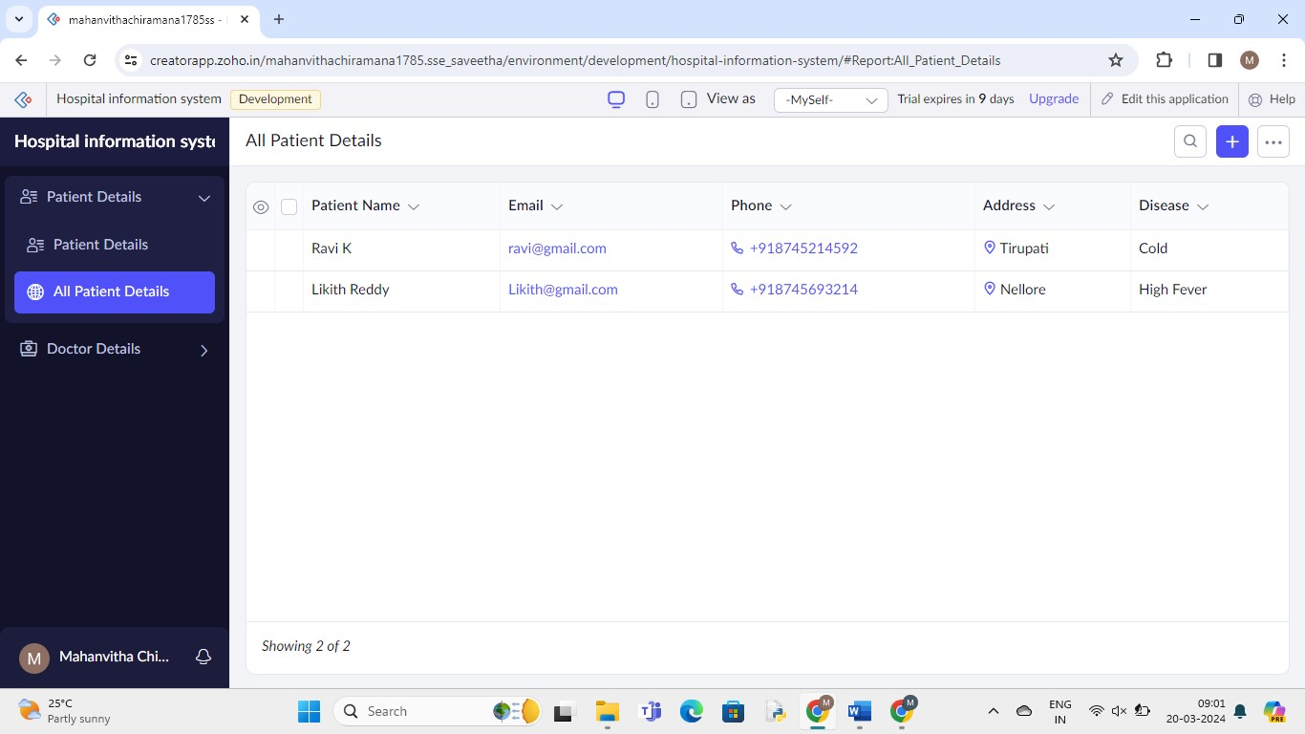

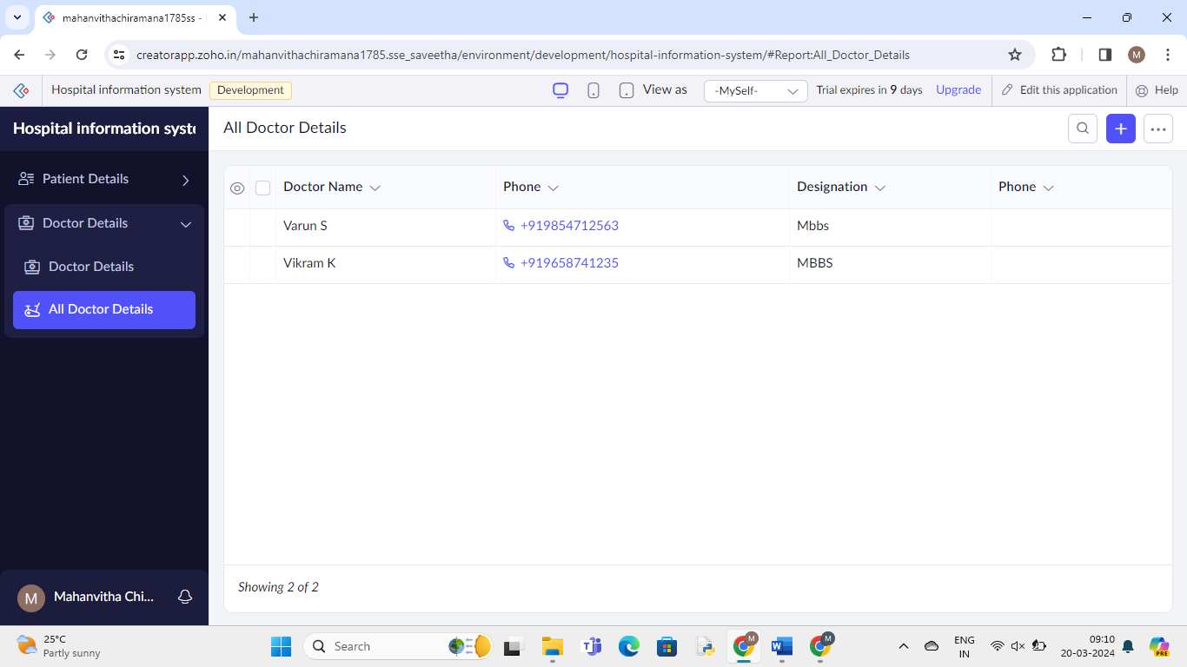

**12.** To Demonstrate virtualization by Installing Type-2 Hypervisor in your device, create and configure VM image with a Host Operating system (Either Windows/Linux).

1.install and setup VM ware software and create a new virtual machine

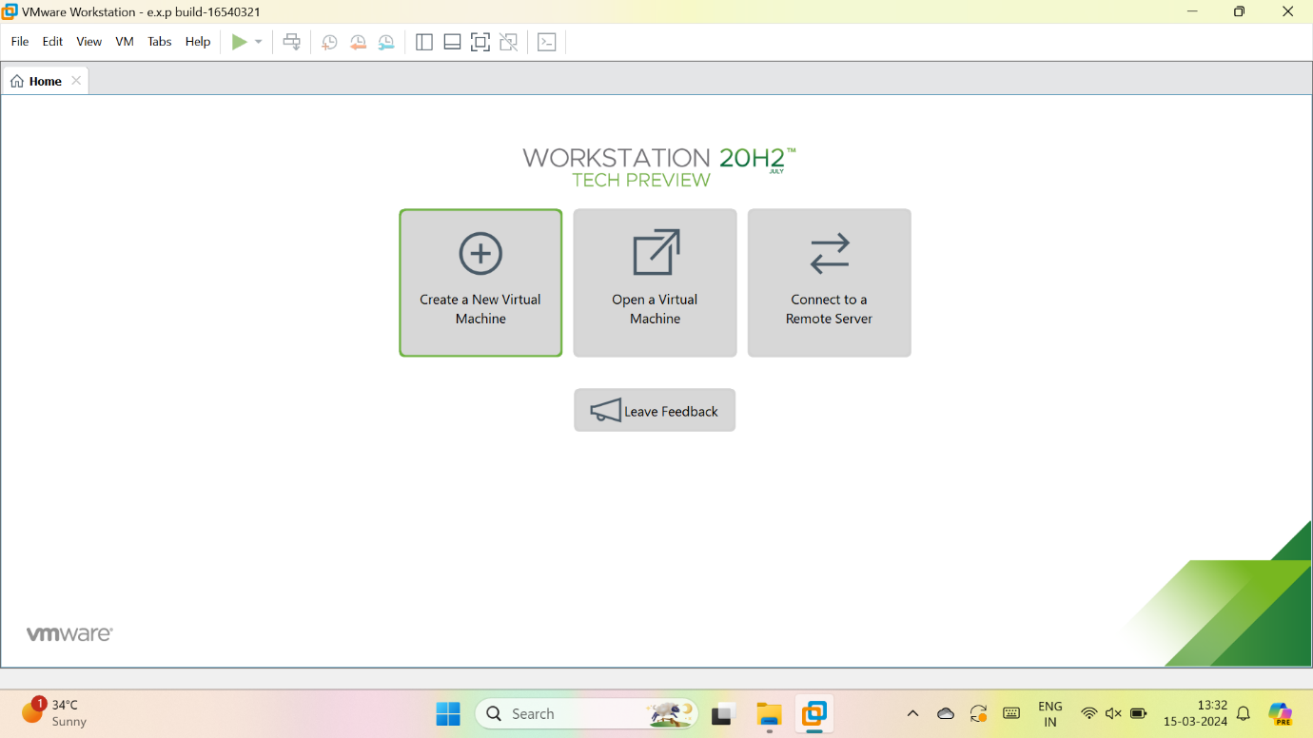

2.select typical

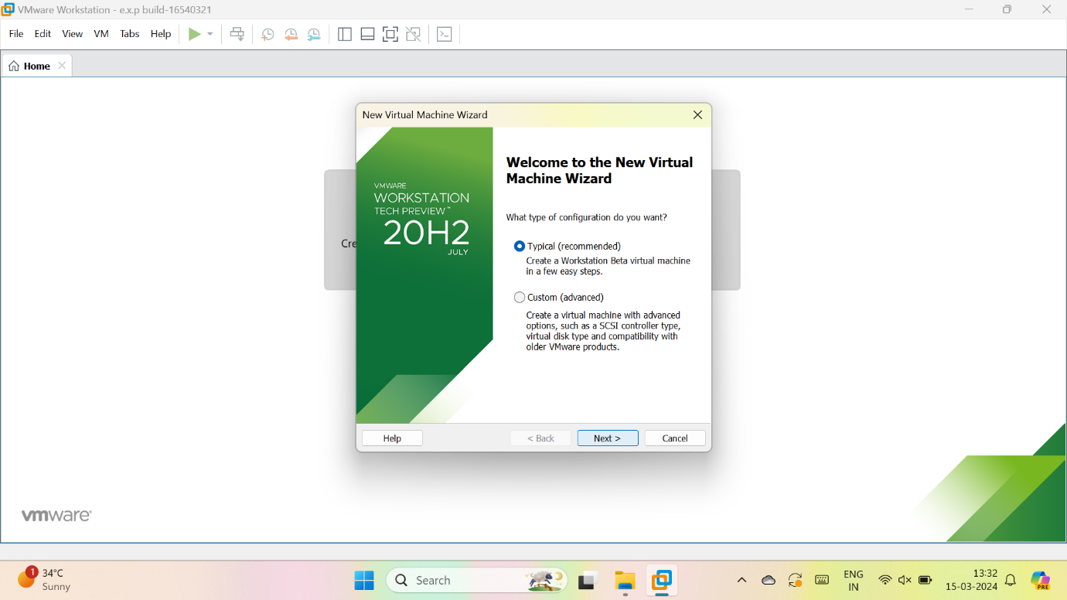

3.we have to select installer disc image and upload image file

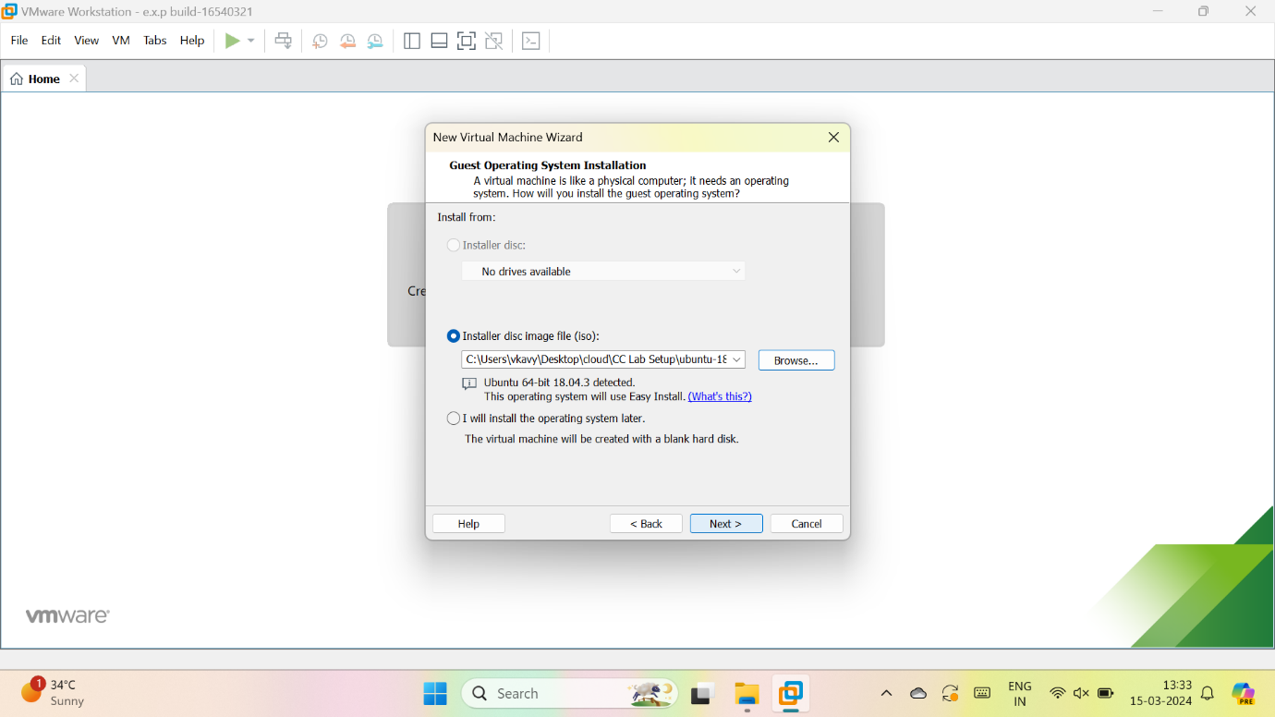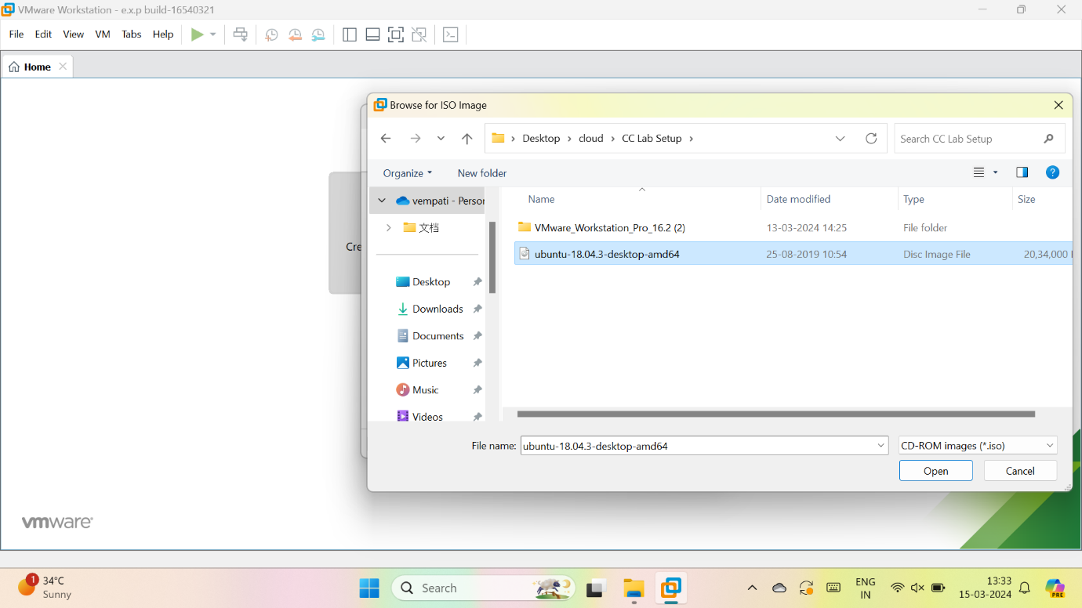

4.give the details for the new os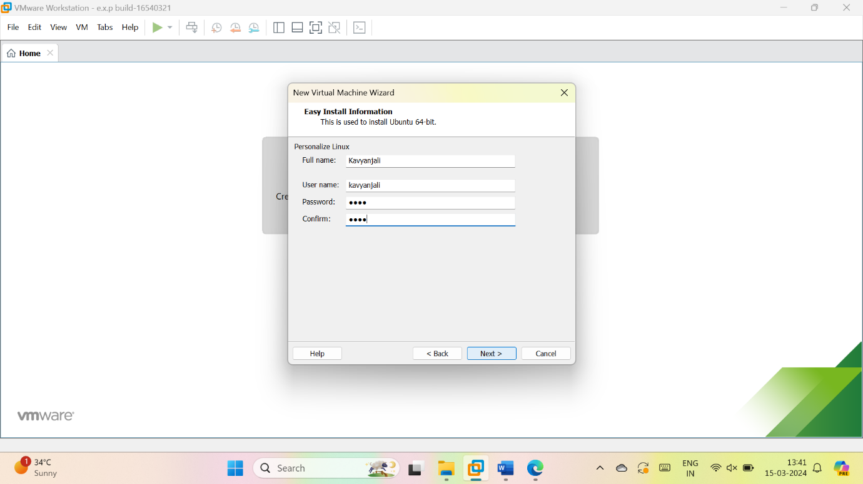

5.give name for VM ware

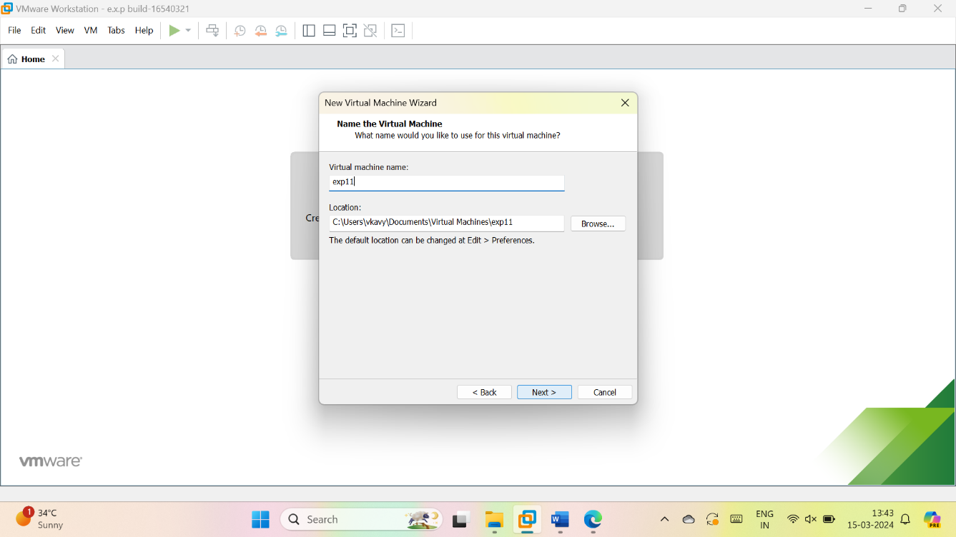

6.give the maximum size of disk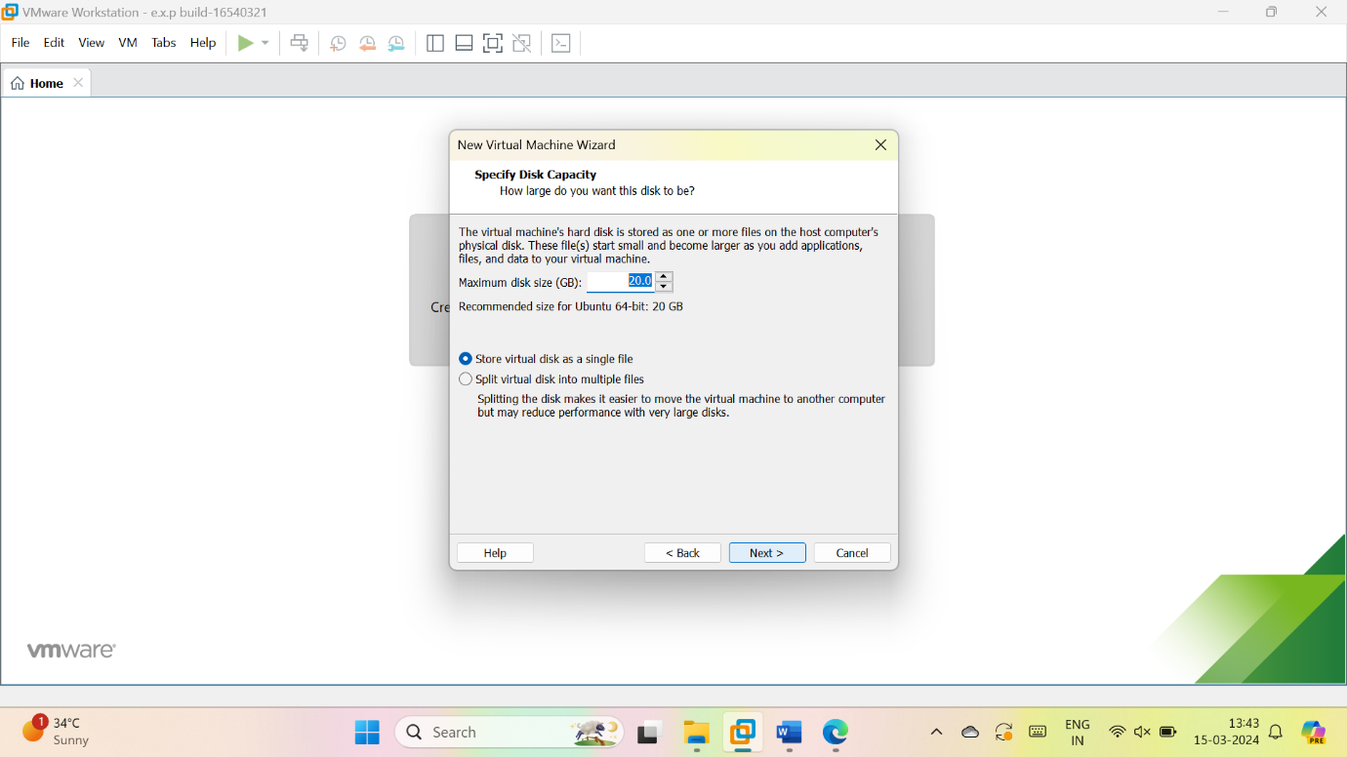

7.check the description

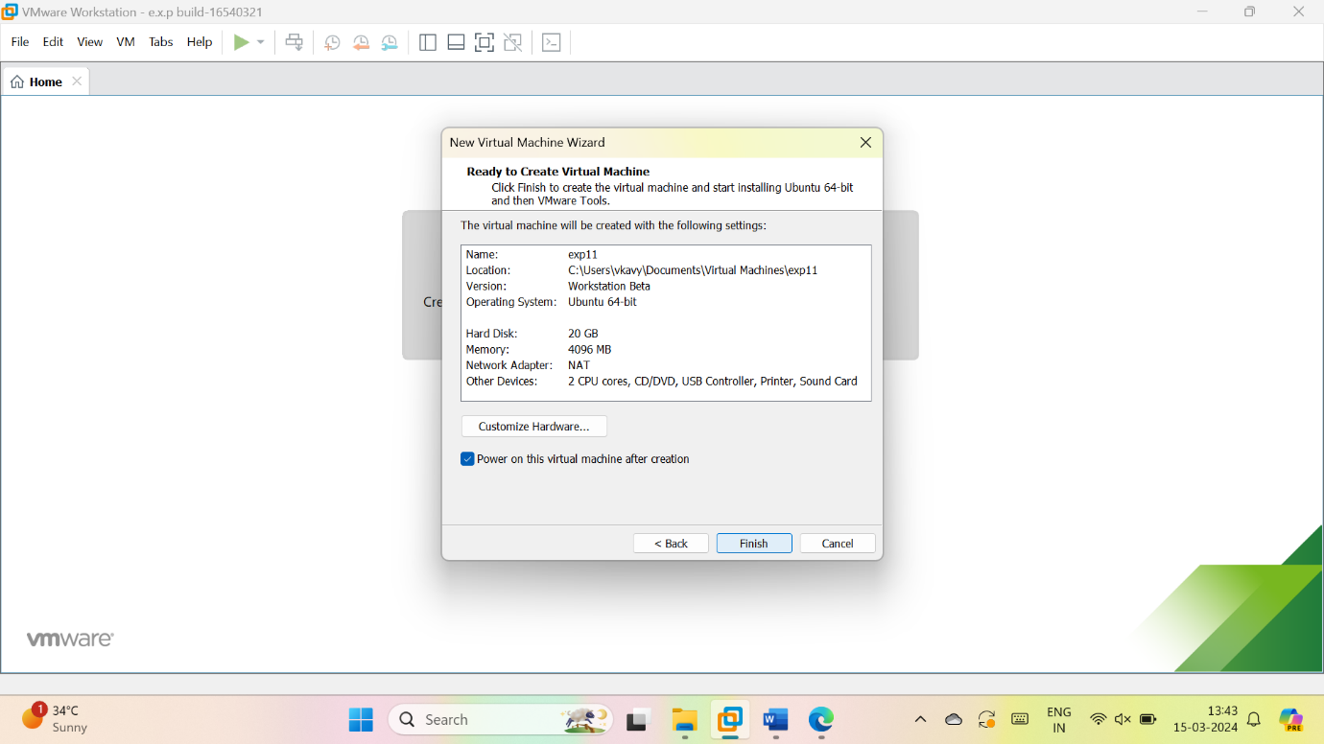

8.if will start loading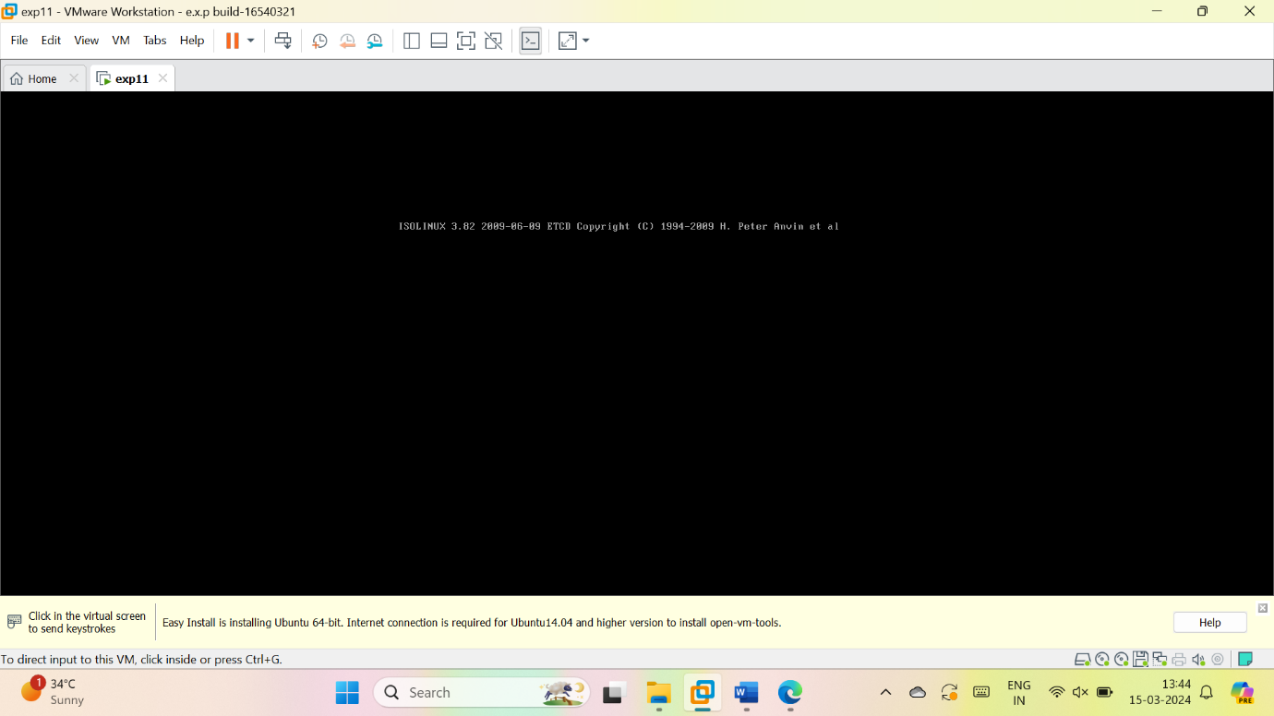

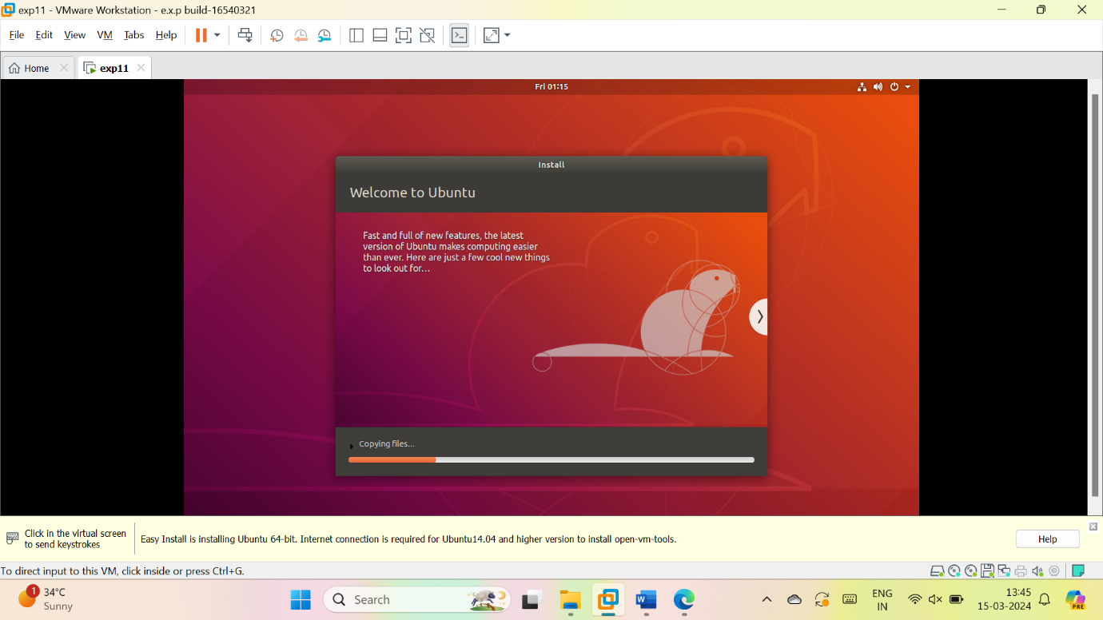

13. Virtual Machine with 1 CPU, 2GB RAM and 15GB storage disk using a Type 2 Virtualization Software.

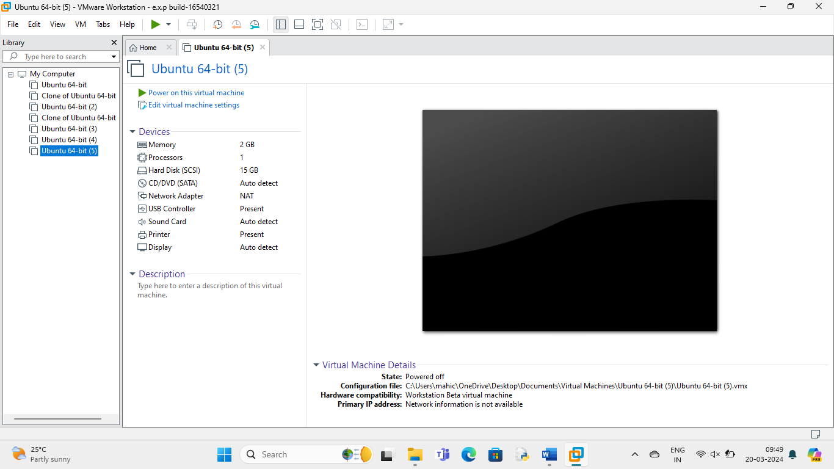

14. Virtual Hard Disk and allocate the storage using VM ware Workstation

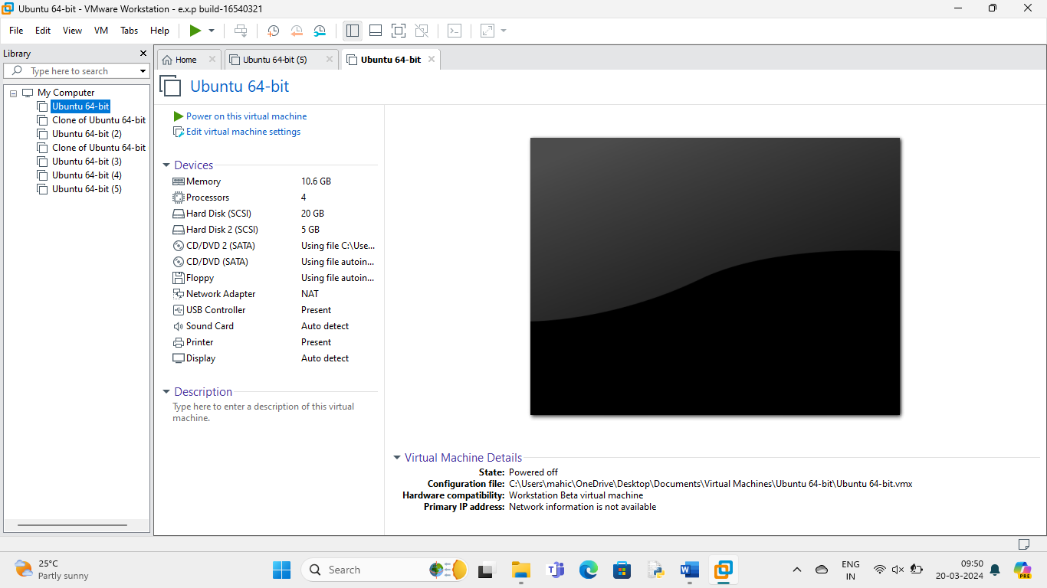

15. Create a Snapshot of a VM and Test it by loading the Previous Version/Cloned

VM

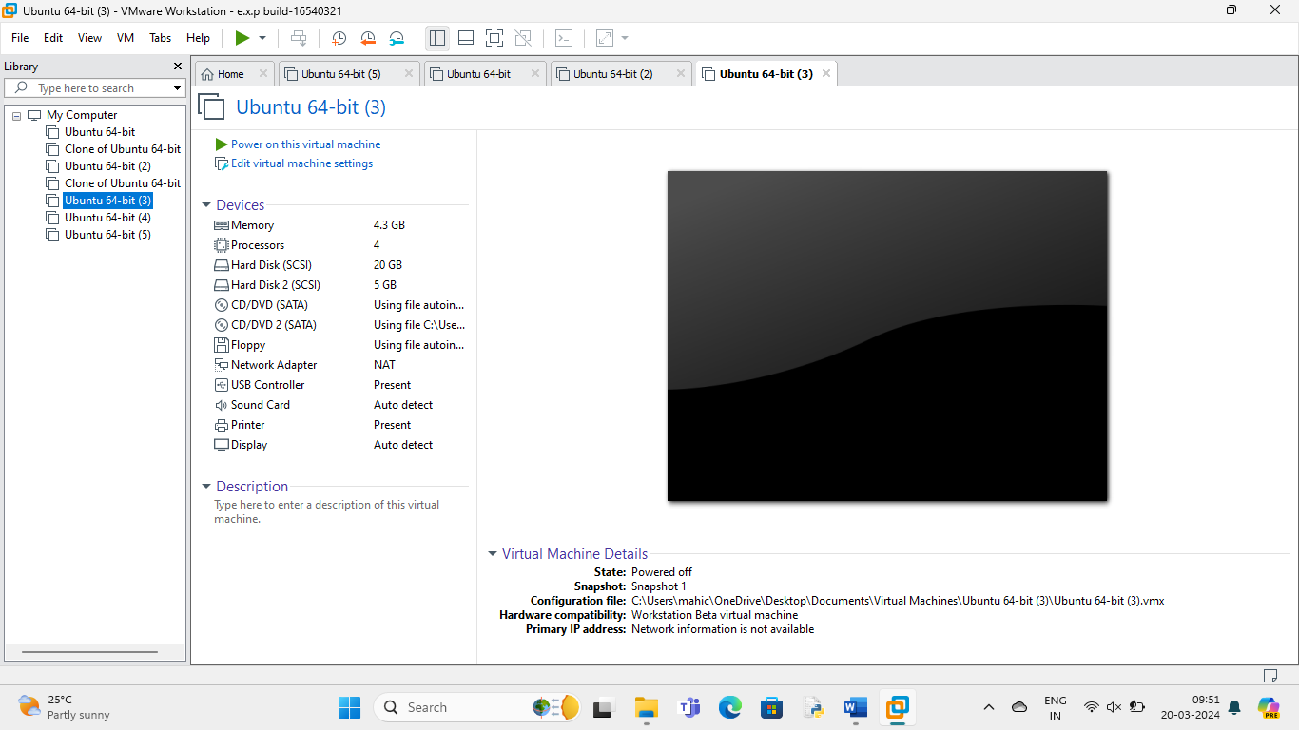

16. Create a Cloning of a VM and Test it by loading the Previous Version/Cloned

VM

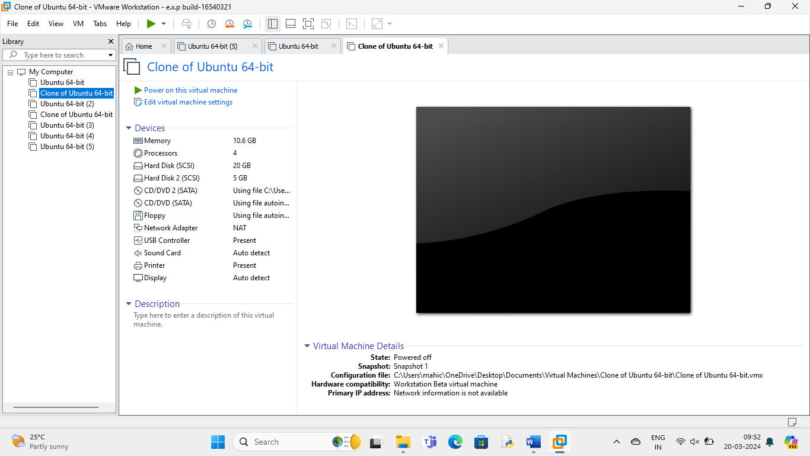

17. Change Hardware compatibility of a VM (Either by clone/create new one) which is already created and configured.

